State of Florida  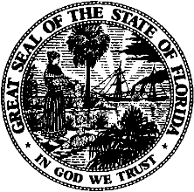 |  | Public Service Commission  Capital Circle Office Center ● 2540 Shumard Oak Boulevard  Tallahassee, Florida 32399-0850  -M-E-M-O-R-A-N-D-U-M-
DATE: | September 24, 2024
TO: | Local Emergency Managers and Law Enforcement Officials
FROM: | Todd M. Brown, Emergency Coordinating Officer,  Emergency Support Function-12 – Energy TMB
RE: | Request for Access to Restoration Areas During Emergency Recovery Operations

It is requested that electric utility restoration personnel, including subcontractors, be granted access to areas where power restoration is needed. Electric restoration personnel should provide local authorities; 1) a valid government-issued ID (driver’s license or passport) and 2) proof of employment (ex: employer credentials or a letter on employer letterhead).

This letter is intended to demonstrate a need to enter areas requiring power restoration, it is not intended to supersede local emergency management and/or law enforcement authorities. This request is limited to restoration efforts presented by TS/Hurricane Helene and is limited to 30 days in duration (with potential extensions).

If there is uncertainty regarding the validity of individuals or entities presenting this letter please contact the Emergency Coordinating Officer or Alternate Coordinating Officer at the State Emergency Operations Center:

Todd Brown 850.901.5599 or Robert Simpson 850.688.3292

