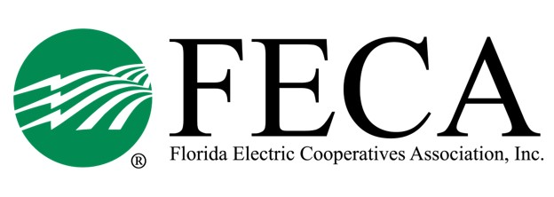
2024 Hurricane Meeting
Hilton Ocala (3600 SW 36th Ave)
Saratoga Room
April 9 - 10, 2024

Tentative Agenda

April 9

01:00 PM Welcome and Introduction Alisia Hounshell, FECA

01:15 PM What is Mutual Aid? FECA

02:00 PM Basecamp Basics Lee Hopkins & Tommy Hopkins
Storm Services

03:00 PM Break

03:15 PM Florida Highway Patrol Capt. Derrick Rahming, Sr.
Emergency Management Emergency Operations Coordinator

04:00 PM Are You Ready? Marie Braun, Florida Keys EC
Steve Garten, ReadyOp Communications

05:00 PM Adjourn

April 10

08:30 AM Hurricane Idalia – Lessons Learned Christine Moor & Mike McWaters, SVEC
Jeff Brewer, TCEC

09:15 AM Storms & Politics Mike Bjorklund, FECA

10:00 AM Break

10:15 AM Unravelling the Spaghetti Mike Boylan, Mike’s Weather Page

11:00 AM FEMA/F-ROC Melissa Foggy, FDEM

11:45 AM Break

12:00 PM Roundtable Wrap Up Alisia Hounshell, FECA

12:30 PM Adjourn

2024 Hurricane Meeting
Attendee List

Central FL EC
Kim Baxley

CHELCO
Matthew Avery
Kevin Wilkerson
Robin Shaw

Clay EC
Mark Townsend
Bryan Gunter
Derick Thomas

Escambia River EC

FL Keys EC
Marie Braun
Tom Anthony
Bill Lee

Glades EC
Colin Evans

Gulf Coast EC
Francis Hinson
Hunter Bailey
Mindy Maddox

LCEC
Karen Vivian
Bryan Sorge
Dennis Davidson
Gary Richardson
Allan Wagner
Varlam Molina
Shane Zubaty

Okefenoke REMC
David Smith

Peace River EC
Van Crawford
Paul Roberts

SECO Energy
Anh Reynolds
John LaSelva
Todd Brown
Tracey Scotto
Wayne Pennington

Seminole EC
Greg McAuley
Timothy Nasello
Jerry McClellan
Jason Lenhart
Cameron Alford
Ryan Hart

Suwannee Valley EC
Mike McWaters
Crystal Ecker
Christine Moor
Trevor Touchton
Scott Sheffield

Talquin EC
Mike Temple
Lisa Burnett
Byon Smiddy

Tri-County EC
Eileen Herndon
Jeff Brewer
John Tuten

West FL EC

Withlacoochee River EC
Cheri Garcia
Doris Melton
Joe Marina
Ricky Gude
Jamen Monbarren
David Gonzalez
Frank Tomkow
Travis Weaver

FECA & Guests
Mike Bjorklund
Alisia Hounshell
Jeff Banka
Drew Love
Forrest Boone

