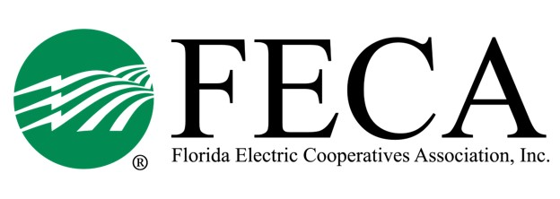
2023 JPA Tabletop Exercise &
Hurricane Meeting
Hilton Ocala (3600 SW 36th Ave)
May 9 - 10, 2023

May 9: JPA Tabletop Exercise
Boxed lunches will be provided (sponsored by CFC) and breaks will be scheduled as needed.

11:00 AM ET Welcome and Introduction Mike Bjorklund, FECA
Executive VP and GM Joint Procurement Agreement (JPA) Randy Shaw, Peace River EC
GM/CEO
Explanation of Exercise Jacques Davignon
Surf Technologies
Scenario 1 – Exercise

Scenario 1 - Debrief

Scenario 2 – Exercise

Scenario 2 – Debrief

Next Steps & Action Items

05:00 PM ET Adjourn

May 10: Hurricane Meeting

08:30 AM ET Welcome and Introduction Mike Bjorklund, FECA
Executive VP and GM

08:45 AM ET Recap Tabletop Exercise Mike Bjorklund

09:30 AM ET Hurricane Ian: Lessons Learned Allan Ruth, LCEC
Manager, Ops Business Support

10:45 AM ET Florida Recovery Obligation Calculation TBD
(F-ROC) Overview FL Division of Emergency Mgmt

12:00 PM ET Lunch – sponsored by CoBank

1:00 PM ET Statewide Storm Issues Mike Bjorklund/Alisia Hounshell
- Mutual Aid Site
- Storm Book
- Labor Shortages
- Supply Shortages

02:00 PM ET Roundtable Wrap-up

02:30 PM ET Adjourn
2023 Hurricane Meeting
Attendee List

Central FL EC
Denny George
Daniel Powell
Jim Beauchamp

CHELCO
Matthew Avery
Kevin Wilkerson
Kevin Jones

Clay EC
Mark Maxwell
Chris Bryan

FL Keys EC
?

Glades EC
Travis Turner

LCEC
Clark Hawkins
Rusty Snider
Allan Ruth

Okefenoke REMC
Travis Page

Peace River EC
Randy Shaw
Paul Roberts
Van Crawford

PowerSouth
Heather Cravey
Patrick McCalman
Meagan Ferut

SECO Energy
Barry Owens
Paula Perry

Seminole EC
Greg McAuley
Charlies Wubbena
Tim Nasello
Kristine Ward
Cameron Alford
Scott Callaway

Suwannee Valley EC
Mike Mcwaters
Crystal Ecker
Mark Mosley
Scott Sheffield
Trevor Touchton
Christine Moor

Talquin EC
Mike Temple
Lisa Burnett
Mike Grice
Terrance Roberts
Rachelle Parramore
Byon Smiddy

West FL EC
Terrell Culbreth
Will Melton

FECA & Guests
Mike Bjorklund
Michelle Hershel
Alisia Hounshell
Jeff Banka
Forrest Boone
Bo Rosser (CFC)

