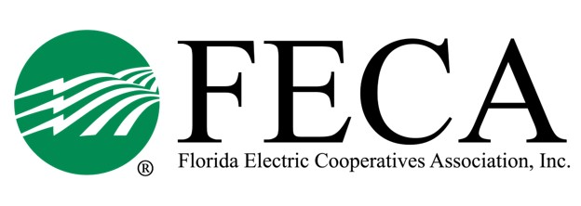
2022 JPA Tabletop Exercise
Hilton Ocala (3600 SW 36th Ave)
November 9, 2022

AGENDA

09:00 AM ET Welcome and Introduction Mike Bjorklund
FECA
Joint Procurement Agreement (JPA) Randy Shaw
Peace River EC
Explanation of Exercise Jacques Davignon
Surf Technologies
Scenario 1 – Exercise

Scenario 1 - Debrief

Lunch

Scenario 2 – Exercise

Scenario 2 – Debrief

Next Steps & Action Items

03:00 PM ET Adjourn

2022 JPA Tabletop Exercise
Attendee List

Central FL EC
Denny George
Daniel Powell
Jim Beauchamp

CHELCO
Matthew Avery

Clay EC
?
?

FL Keys EC
Michael Roberge

Glades EC
Travis Turner

Gulf Coast EC
Francis Hinson
Gayla Burge
Justin Barnes

Okefenoke REMC
David Smith
Travis Page

Peace River EC
Randy Shaw
Tucker Lemley
Paul Roberts
Van Crawford

PowerSouth Energy
Patrick McCalman
Heather Cravey
Meagan Ferut

SECO Energy
Gregg Morrell
Barry Owens
Paula Perry

Seminole EC
Greg McAuley
Charlies Wubbena

Suwannee Valley EC
Mark Mosley
Scott Sheffield

Talquin EC
Tracy Bensley
Mike Temple
Lisa Burnett
Mike Grice
Terrance Roberts
Byon Smiddy

Tri-County EC
Jeff Brewer
John Tuten

West FL EC
Keith Varnum
Darrell Creel

Withlacoochee River EC
Marlin Sexton
Linda Mann

FECA & Guests
Mike Bjorklund
Michelle Hershel
Alisia Hounshell
Jeff Banka

