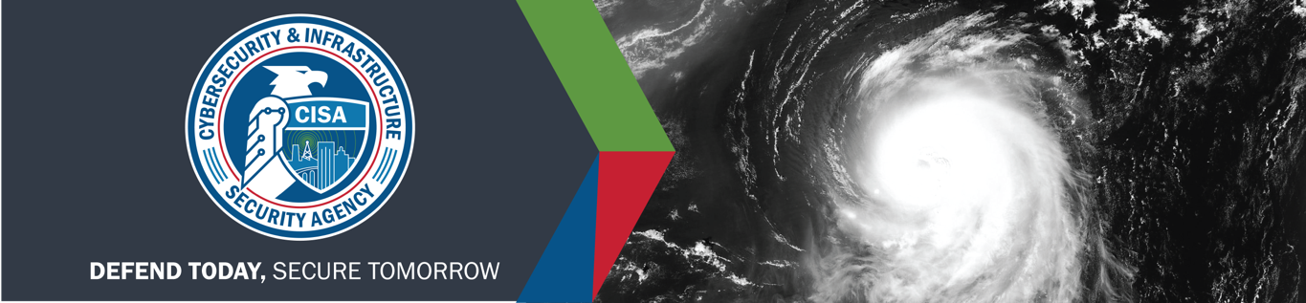

WEBINAR: CRITICAL INFRASTRUCTURE HURRICANE RESPONSE DURING A PANDEMIC

You are invited to join the Cybersecurity and Infrastructure Security Agency (CISA), FEMA, and NOAA as we prepare for an unusual hurricane season. Join us to learn about:

* A coordinated federal approach to infrastructure response and recovery in a hurricane through ESFs 2 and 14, as well as FEMA’s NBEOC
* Special considerations in a COVID environment
* Risks to interdependent critical infrastructure systems

DATE

Thursday, June 18, 2020

TIME

10:30 am to 12:00 pm EDT

LOCATION

HSIN Connect

REGISTRATION

[Register here](https://www.eventbrite.com/e/cisa-2020-hurricane-webinar-tickets-109655021120)

**EVENT DETAILS**



* NOAA’s hurricane season forecast

Intended Audience

Government and industry decision makers and others involved in infrastructure response and recovery at the national, regional, and local levels.

CISA CENTRAL

Cybersecurity and Infrastructure

Security Agency (CISA)

Office: 703.235.8910

Email: [Central@cisa.gov](mailto:Central@cisa.gov)