Activation and Termination of Control Center Sequestration

*This document is classified as CONTROLLED and contains protected information intended solely for use by authorized New York Power Authority (NYPA) personnel. Physical or electronic access requires prior authorization. Disclosure, copying or distribution of this document, or the taking of any action based on its contents by unauthorized personnel is strictly prohibited.*

|  |  |  |  |
| --- | --- | --- | --- |
| Revision Date (For Ops Use Only) | Revision # | Description/Modification | Author |
| [Revision Date] | 1 |  |  |
|  | 0 | Issued original version O-PS-40-002 | Phil Toia  SVP, Power Supply |
| Refer to last page of document for electronic approvals of latest revision. | | | |

# Purpose

The purpose of this Procedure is to establish a decision-making mechanism for activating, and then terminating, control center (a.k.a control room) sequestration procedures that may be required for staffing and operating NYPA’s transmission and generation control centers in a pandemic that threatens control center operational continuity.

A key consideration for the purpose of this Procedure is the importance of maintaining situational awareness of the NYPA’s generaton and transmission assets in support of the NYISO and the entire New York State grid. That capability can be adversely affected if the staff manning NYPA’s control centers (rooms) are infected by a pandemic illness or are required to shelter-in-place (at home) to reduce the spread of the illness. In a pandemic, an infection of one control center (room) operator may require that an entire shift of operators be required to shelter-in-place (at home) for a long period. Making a decision to operate some or all of NYPA’s control centers (rooms) in a sequestered state is a key risk management action for NYPA and the State of New York, in the face of considerable uncertainty.

This Procedure supports actions that might be taken under NYPA’s Pandemic Plan and its related procedures, including but not limited to:

* NYPA Pandemic Plan (February 2020)
* O-PS-40-001: Designation of a Biological Contamination Controlled Area (BCC Area) Within a NYPA Facility
* O-PS-40-003: Sequestration Procedure – Central New York Region - Clark Energy Center - Energy Control Center and Emergency Energy Control Center
* O-PS-40-004: Sequestration Procedure – Western New York Region - Niagara Power Project Control Room
* O-PS-40-005: Sequestration Procedure – Northern New York Region - St. Lawrence-FDR Power Project Control Room
* O-PS-40-006: Sequestration Procedure – Central New York Region - Blenheim-Gilboa Power Project Control Room
* O-PS-40-007: Sequestration Procedure – Southeast New York Region Control Rooms

# SCOPE

Control center (room) shift personnel working in proximity for extended periods can be proactively isolated in order to limit their chances of exposure to a pandemic agent. There are different means of isolation of control center (room) staff that might be employed; shelter-in-place, self-quarantine, and sequestration. The definitions of these isolation mechanisms are included, for the sake of clarity, in Section 4 – Initialisms and Definitions. This Procedure focuses on the decision-making process to activate sequestration of staff at some or all of NYPA’s control centers (rooms).

Application of this Procedure is likely to be required during a Major Pandemic Emergency (MPE). An MPE may pose a significant risk to NYPA’s employees, retirees and others that may exceed the capabilities of NYPA to maintain business continuity and to provide the coordination necessary to utilize all of the capabilities of the company. This Procedure addresses one element of the business related to control center operational continuity.

This Procedure provides the basis for management to activate, and then terminate, sequestration of staff at one or more of its controls centers. The Procedure also outlines the decision and initial sequestration implementation actions for the management teams that have responsibility for operating the control centers (rooms) located at the Energy Control Center (ECC) and the Regions (Western, Northern, Central, and Southeast New York). Separate procedures, as outlined in Section I – Purpose, have been written for the actions required to implement and manage sequestration at each of NYPA’s control centers (rooms).

# APPLICABILITY

This Procedure applies to all NYPA employees and contractors that work in or support the operation of NYPA’s control centers (rooms) located at the Energy Control Center (ECC) and the Regions (Western, Northern, Central, and Southeast New York).

All ECC and Region actions taken in response to a control center (room) sequestration order by management will be communicated to the NYISO and will support NYPA’s role as a registered Transmission Owner (TO), Generator Owner (GO) and Generator Operator (GOP) for its facilities interconnected with the Bulk Electric System (BES).

# INITIALISMS AND DEFINITIONS

BES – Bulk Electric System. Generally speaking, all transmission elements operated at 100 kV or higher and any generator(s) with an individual nameplate greater than 20 MVA or plant aggregate nameplate greater than 75 MVA that connect to 100 kV or higher.

Biological Contamination Controlled Area (BCC Area). A BCC is a controlled area of the facility within which only on-site sequestered personnel are normally allowed to enter and work. Only individuals who have exhibited no signs or symptoms of disease during a previous isolation period are normally permitted to enter a BCC Area (such as a control center (room)). BCC Areas are posted conspicuously with postings that are clearly distinct from other types of facility postings and which identify the area as a BCC Area. BCC Areas are preferably areas physically isolated from non-BCC Areas. However, in some cases if such boundaries do not exist, an equivalent boundary can be created by establishing a "Buffer Zone" of three to five feet in width between BCC Areas and non-BCC Areas. It is not necessary to isolate the ventilation system of a BCC area from other areas.

ECC – Energy Control Center

GO – Generator Owner

GOP – Generator Operator

Major Pandemic Emergency (MPE) - A pandemic threat condition that poses significant risk to NYPA’s employees, retirees, and others. The impact of an MPE may exceed the capabilities of NYPA to maintain business continuity and to provide the coordination necessary to utilize all of the capabilities of the company. It is anticipated that Pandemic Readiness Level PR-4 and above would constitute a major pandemic emergency.

NYISO – New York Independent System Operator

NYPA – New York Power Authority

NYS – New York State

Pandemic - Human infections causing a global outbreak of serious illness. Because there is little natural immunity, a disease can spread easily from person to person.



Pandemic Readiness (PR) Levels - A set of protocols referred to as "readiness levels" has been developed that outlines the pandemic threat to NYPA operations. These readiness levels were developed to cover the range of pandemic threat conditions NYPA can be expected to encounter such as no pandemic threat within the next six months to severe conditions in which absenteeism rate is projected to be or actually is over 15%. For each escalation in readiness level, further actions will likely be implemented as the situation dictates. These levels are referenced below:

**Table of PR Levels** (to be reviewed and agreed to by NYPA team)**:**

|  |  |
| --- | --- |
| PR – 1 | Risk to NYPA is Low. No pandemic threat to NYPA within next 6 months. |
| PR – 2 | Risk to NYPA is Moderate. Absenteeism in normal range and pandemic source could impact NYPA within next 3 months. |
| PR – 3 | Risk to NYPA is High. Absenteeism projected or actually between 3-5% |
| PR – 4 | Absenteeism projected or actually between 5-10% |
| PR – 5 | Absenteeism projected or actually between 10-15% |
| PR – 6 | Absenteeism projected or actually > 15% |

Regions – NYPA’s Western, Northern, Central and Southeastern (SENY) Regions

Social Distancing - Measures to increase the space between people and decrease the frequency of contact among people. It may serve as a first line of defense to help delay or mitigate the spread of influenza. It does not involve vaccines or medications (also called non-pharmaceutical interventions). These measures can include: closing schools, canceling public gatherings, planning for liberal work leave policies, telecommuting, voluntary isolation of cases, and voluntary quarantine of household contacts.

Self-quarantine – An isolation of personnel that may follow possible exposure to a positive case of the pandemic source or the onset of symptoms. An individual must remain in isolation from interpersonal contact and cannot leave his/her designated area of quarantine (i.e. their home).

Sequestration – A proactive, extended isolation of personnel to perform their job function with no confirmed exposure risk and no symptoms of the pandemic source. In sequestration, no movement beyond the designated sequestration area and no interpersonal contact with individuals outside the defined area for the designated period is allowed.

Shelter-in-place – An isolation in which personnel that are suspected of having or do have the pandemic illness remain in private residence with immediate family members only or are isolated on-site from other workers. Travel outside the home is only allowed for essential needs and functions including food, medicine, and work deemed critical. This form of movement restriction is largely consistent with state-level orders and directives. If shelter-in-place on-site is required for personnel, travel is not allowed.

TO – Transmission Owner

TOP – Transmission Operator

# Procedure Implementation

Implementation of this Procedure hinges on the establishment of a Biological Contamination Controlled Area (BCC Area) within one of NYPA’s operating facilities pursuant to OP XXX-XX-001. The designation of a NYPA control room or control center as a BCC Area is a precursor to the implementation of this Procedure (refer to O-PS-40-001).

As stated, this Procedure was developed to assist management in determining if and when to activate, and then terminate, sequestration of control center (room) personnel for one, some, or all of NYPA’s control centers (rooms). As stated, separate procedures, as outlined in Section I – Purpose, have been written for the actions required to implement and manage sequestration at each of NYPA’s control centers (rooms), after the decision has been made.

Application of this Procedure hinges on the classifications of the personnel that are required to respond to a pandemic as described in Section 5.1 – Classification of Sequestered Personnel and the thresholds and criteria NYPA has established under Section 5.2 – Decision Thresholds and Criteria for deciding when to sequester control center (room) staff. The responsibilities of Executive Management and management teams at the ECC and the Regions in supporting the decision and the initial steps to implement the decision are outlined in Sections 5.3 – 5.4.

## Classifications of Sequestered Personnel

* + 1. On-site Sequestered Personnel

Classification that identifies staff required to fulfill regulatory required and other critical functions onsite at a facility. They may be required for direct hands-on operation of critical equipment, maintenance or security in a facility or as support to such operations. They follow administrative controls for ensuring no cross contamination occurs between themselves and others. They practice social distancing, maintain a "clean" work environment, and in some instances wearing the NYPA issued mask (surgical mask or respirator) while onsite. Staff attempts to maintain a healthy environment when not on job site as appropriate. Sequestered employees are subjected to a health sequester period, the period to be determined based on the pandemic source, before being allowed contact with other sequestered employees.

* + 1. On-site Support Personnel

Classification that identifies personnel that work on-site, normally interacts with the public, or normally visits public facilities. This staff works normal or modified schedule. They follow administrative controls for ensuring no cross contamination occurs between themselves and others. They practice social distancing, maintain a "clean" work environment, and in some instances wear a NYPA-issued mask while at work. Staff attempts to maintain a healthy environment when not on the job site as appropriate. NYPA implements measures to maintain a "clean" work environment but does not provide housing and food to on-site support staff..

* + 1. Off-site Support Personnel

Classification that identifies staff needed for support of operations, maintenance or security of the facility or system but is NOT required at the facility or job location. A portion of the off-site support staff (telecommuting) would require electronic access to NYPA systems and work rules to allow operation from home.

## Control Center (Room) Sequestration Activation Decision Considerations

Making a decision to activate sequestration of the staff for some or all of NYPA’s control centers (rooms) in the face of a MPE is subject to many variables and uncertainties. The key thing to consider is that a pandemic infection of one control room operator can require the shelter-in-place (at home) for a long period of all of the personnel on the shift with the infected operator. Thus, from a risk management perspective, management will want to be conservative in making a decision to activate sequestration. In general, from an operations perspective, sequestering the control center (room) staff may be the last option to ensure control center (room) continuity.

The following considerations are listed as possible thresholds or criteria to be used in reaching a decision to activate sequestration.

* + 1. Initial Consideration – Absenteeism for the Facility with the Control Center (Room)

Since a MPE is very likely to cause higher than normal absenteeism, an initial threshold for a decision to operate a NYPA control center (room) in a sequestered state is tied to the absenteeism rate for the entire facility in which the control center (room) resides. For the purposes of this Procedure a decision to operate in a sequestered mode should be considered when the PR level for a NYPA facility with a control center (room) reaches Level 3.

Depending on the circumstances of the pandemic, e.g. the virulence of the pandemic source, the initial screening threshold for absenteeism rate may be lower or higher. As stated, the potential for loss of an entire operator shift due to an infection of one operator may require that less emphasis be placed on using absenteeism rate as a hard and fast threshold.

* + 1. Additional Considerations

Other considerations in making such a decision to activate sequestration include, but are not limited to:

* A decision to activate sequestration should consider how long it can be sustained with the staff that are available to support it, either those who may volunteer or may be forced to support it.
* The level of community spread of the pandemic illness within the vicinity of the facility in which the control center (room) resides.
* The number of confirmed cases in the community around a NYPA facility with the control center (room).
* The number of confirmed cases in New York State.
* Any New York State emergency directives that apply to NYPA’s operations.
* Any municipal emergency orders issued by municipal entities within the vicinity of the NYPA facilities that have a control center (room).
* Any NYISO directives that require operation of the NYPA control center (room) to ensure BES reliability during the pandemic.
* The reputational risks of either taking or not taking action to ensure continued operation of the affected NYPA control center (room) (e.g. support the NYISO).
  + 1. Final Consideration – Results of Pandemic Illness Tests of Control Center (Room) Staff

If the considerations in Sections 5.2.1 and 5.2.2 lead management to make a decision to activate sequestration for some or all of NYPA’s control centers (rooms), one final action shall be taken to confirm the decision. Generally, a decision to sequester control center (room) staff to perform their job function should not be made unless it is possible to confirm that those staff that will be sequestered test negative for the pandemic illness.

Testing for the pandemic illness assumes:

* Tests have been developed that can identify the presence of the pandemic illness in a person,
* The test kits are available and can produce results in a timely manner to support the sequestration, and
* NYPA has support from a government agency (e.g. New York State Department of Health) and health professionals that can administer the tests to the staff that have been selected to participate in the sequestration.

If testing of the control center (room) staff is not possible, then a decision to sequester them might be postponed in lieu of enforcing other measures to limit the spread of the pandemic illness, e.g. social distancing, regular cleaning and disinfection of the work areas, personal hygiene, and use of personal protective equipment.

## Termination of Control Center (Room) Sequestration

When the pandemic has ceased or its effects have substantively reduced the impact on the staffing of NYPA’s control centers (rooms), the order to operate one or more of NYPA’s control centers (rooms) in a sequestered state shall be terminated by the Director of System Operations and/or the Regional Manager, after consultation with the SVP Power Supply.

## Executive Responsibilities

The SVP Power Supply or his designee, in consultation with the Chief Operating Officer and the President and Chief Executive Officer, has the responsibility to decide when to operate one or more of NYPA’s control centers (rooms) in a sequestered state based on 1) the sequestration activation decision considerations provided in Section 5.2 of this Procedure and 2) the staffing requirements for operation of the control centers (rooms) provided by the ECC and Regions management teams. Information that would be required to ensure proper operations of the control centers (rooms) would include, but not be limited to:

* The number and classification of essential staff (employees and contractors) required.
* The number of on-site sequestered, on-site support, and off-site support personnel.
* The minimum number of staff (employees and contractors).

## ECC and Regions Management Team Responsibilities

The responsibilities of the ECC and Regions management teams, led by the Director of System Operations and the Regional Managers, in supporting a decision to operate one or more of NYPA’s control centers (rooms) in a sequestered state include:

### Monitor and provide daily updates to the SVP Power Supply on control centers (rooms) absenteeism rates.

### Monitor and provide daily updates to the SVP Power Supply on control center (room) staff that are confirmed to have the pandemic illness and that have been required to shelter-in-place at home and for what period of time.

### Monitor and provide daily updates to the SVP Power Supply on the number of confirmed pandemic cases in the vicinity of the affected NYPA facility with the control center (room).

### Monitor and provide daily updates to the SVP Power Supply on emergency orders issued by the state and municipal entities within the vicinity of the affected NYPA facility with the control center (room).

### Once a decision is made to operate one or more of NYPA’s control centers (rooms) in a sequestered state, the ECC and Regions management teams, led by the Director of System Operations and the Regional Managers, shall take the following actions:

* + - 1. Issue an order to activate the facility’s sequestration procedure (e.g. O-PS-40-003 Sequestration Procedure – Central New York Region – Clark Energy Center – Energy Control Center and Emergency Energy Control Center).
      2. Report daily to the SVP Power Supply on the status of the implementation of the site’s sequestration procedure.

# REQUIRED COMPLIANCE INFORMATION

The following shall be established and/or maintained to ensure that this Procedure remains effective:

* + NYPA’s Pandemic and Business Continuity Plans
  + Pandemic and Business Contnuity Plans for NYPA’s Operating Facilities
  + NYPA’s Emergency Management Policies and Procedures
  + NYPA’s Bargaining Unit Agreements with provisions to support sequestration of NYPA’s control center (room) staff
  + The Procedure is tested annually, in a tabletop or functional exercise, as part NYPA’s Emergency Management Program
  + Other policies and procedures required to support control center (room) sequestration actions are maintained and referenced in this Procedure.

# Expiration AND DATA RETENTION

This document must be reviewed at least annually, or as business needs require. If there are no changes upon the completion of the annual review, this shall be noted in the revision table.

Records will be retained in accordance with NYPA’s approved records retention schedules and/or in compliance with all applicable legal requirements pertaining to NYPA.

**Revision cycle: Every Year**

# Attachments

* 8.1 - List of NYPA’s Control Centers (Rooms)

NYPA Facilities with control centers (rooms) (refert to Figures 8.1.1 – 8.1.7):

* Clark Energy Center (Energy Control Center)
* Niagara Power Project (hydropower)
* St. Lawrence FDR Power Project (hydropower)
* Blenheim-Gilboa Punped Storage Project (hydropower)
* Eugene W. Zeltmann Power Project (gas/oil)
* Richard M. Flynn Power Plant (gas/oil)

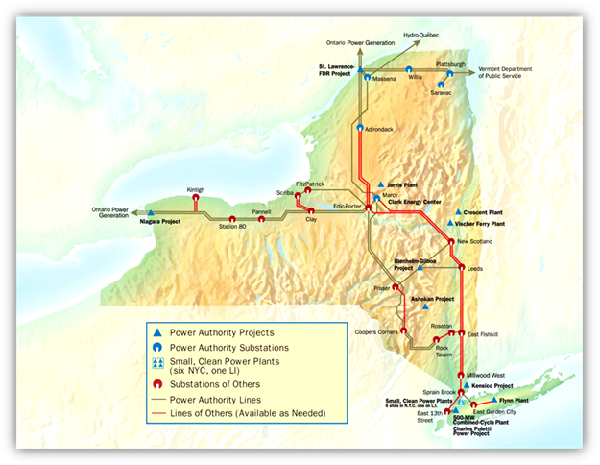

**Figure 8.1.1:** Map of NYPA’s Generation and Transmission Facilities (update required)

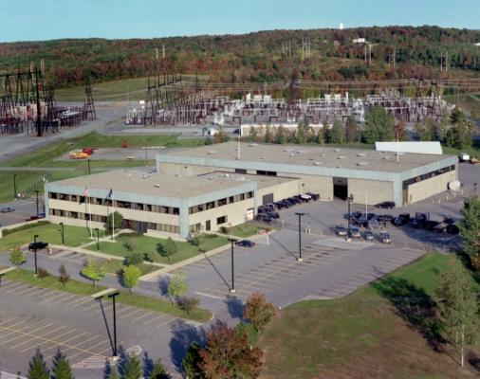

**Figure 8.1.2:** Clark Energy Center, Marcy, NY (Energy Control Center and Emergency Energy Control Center (latter not shown))

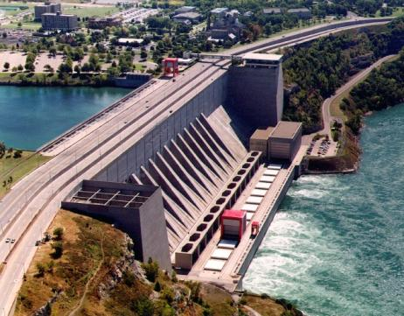

**Figure 8.1.3:** Niagara Power Project, Lewiston, NY



**Figure 8.1.4:** St. Lawrence-FDR Power Project, Massena, NY



**Figure 8.1.5:** Blenheim-Gilboa Pumped Storage Project, Schoharie County, NY

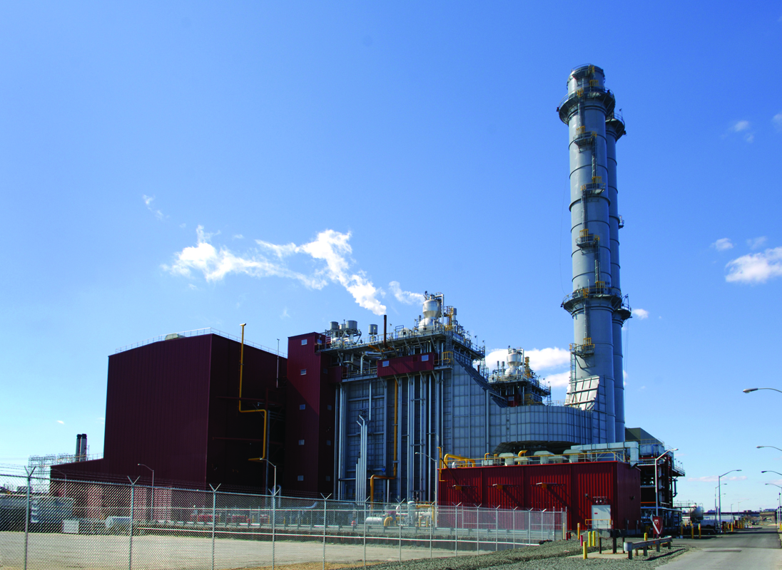

**Figure 8.1.6:** Eugene W. Zeltmann Power Project, Astoria, NY

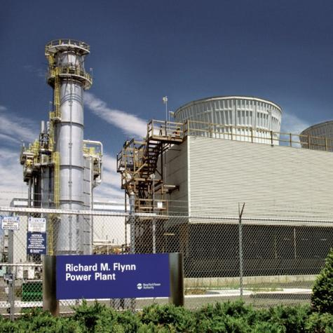

**Figure 8.1.7:** Richard M. Flynn Power Project, Holtsville, NY

* 8.2 - New York State Department of Health Contact(s) – for

The web address for the New York State Department of Health (NYSDOH) is <https://www.ny.gov/services/health>.

Specific contacts within the NYSDOH for support for pandemic illness testing include the following:

…… (to be provided)

…… (to be provided)

* 8.3 - List of References (more complete reference information to be provided)
* NYPA Corporate Pandemic Plan
* Regional Pandemic Plans
* NYPA Corporate Business Continuity Plan
* Regional Business Continuity Plans
* Emergency Management Policies
* CP 8-2 Corporate Emergency Management Policy
* O-EM-20-000 Emergency Management Program Administration[1]
* O-EM-22-000 Emergency Management – Mitigation1
* O-EM-23-000 Emergency Management – Preparedness1
* O-EM-24-000 Emergency Management – Response1
* O-EM-25-000 Emergency Management – Recovery1

1. Utility Operations Business Unit policy.