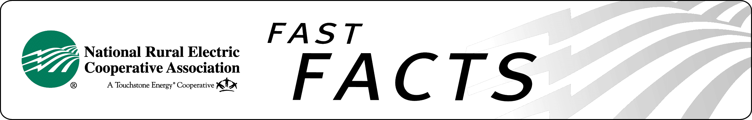

Comprehensive Freight Railroad Transportation Reform

A Solution At Hand

Cooperative Rail Shippers Suffer Monopoly Abuse
The nation’s antitrust laws are meant to protect consumers and the overall public interest from anticompetitive behavior by businesses, but railroads are exempt and do not play by the same rules. The railroads’ antitrust exemptions are antiquated, have no public policy justification and allow anticompetitive conduct. The resulting lack of competition, together with the Surface Transportation Board’s ineffectiveness, has allowed freight railroads to reap huge profits from electric cooperatives and other industries with no marketplace consequences or legal accountability for their unreliable service and exorbitant rates and fees. Legislative reform is required.

Electric Cooperative Consumers Paying the Price
At several generation and transmission co-ops, low coal stockpiles due to poor freight rail service have threatened the reliability of the electric system. Some have even been forced to buy more expensive foreign coal because they can’t rely on railroad deliveries from the Powder River Basin – the richest source of low-sulfur coal in the world. When replacement coal is unavailable, co-ops must rely on more expensive natural gas. Both alternatives drive up consumer bills.

“A 2006 General Accounting Office Report found that shippers in many geographic areas ‘may be paying excessive rates due to a lack of competition in these markets.’ These unjustified cost increases cause consumers to suffer higher electricity bills because a utility must pay for the high cost of transporting coal, result in higher prices for goods produced by manufacturers who rely on railroads to transport raw materials, and reduce earnings for American farmers who ship their products by rail and raise food prices paid by consumers.”
– Sen. Herb Kohl (D-WI), January 2011

A Solution to Unfair Treatment of Rail Shippers

Part 1: Surface Transportation Board Reauthorization

Senate Commerce Chairman Jay Rockefeller (D-WV) has reintroduced Surface Transportation Board reauthorization legislation (S. 158). The Commerce Committee reported this legislation in the 111th Congress, but the bill was not passed before final adjournment. This legislation, which may be a starting point for debate in 2011, would give captive rail customers two of the three major improvements they sought:

- Expand the size of the Surface Transportation Board (STB) from three to five Board members, increases the funding level of the STB and ensure that the Board will become more pro-active and more focused on and responsive to captive rail customer problems;

- Improve rail customer access to competing rail systems through reciprocal switching, mandatory quoting of bottleneck rates to captive rail customers, a process at the STB for removing existing paper barriers and a ban on future paper barriers. Paper barriers are “tying” agreements between a major railroad and a short line railroad requiring all traffic on the short line to use the major railroad even if the short line has access to a competing major railroad.

Captive rail customers’ third major objective was improving the rate challenge process. Senate legislation considered in 2010 contained some minor improvements for large captive rail customers and significant improvements for small captive rail customers. Rail customers will work to improve the rate challenge process provisions if the opportunity arises.

Part 2: Railroad Antitrust Enforcement Act

NRECA supports legislation that:

- Repeals railroad exemptions from antitrust statutes, making railroads fully covered like other industries.
- Permits the U.S. Justice Department and the Federal Trade Commission to review rail mergers under antitrust law.
- Allows state attorneys general and private parties to sue to halt anticompetitive conduct.

Under the “Railroad Antitrust Enforcement Act” (S. 49) introduced by Sen. Herb Kohl (D-WI), the railroads would have six months to review their anticompetitive practices to bring them into compliance with the nation’s antitrust laws. After that time, the railroads would be subject to the same penalties as other industries. This would allow electric cooperatives harmed by the railroads’ market manipulations the right to bring an antitrust action in federal district court to stop practices that violate the nation’s antitrust laws.

Status: Sen. Kohl reintroduced the “Railroad Antitrust Enforcement Act” (S. 49) in January 2011. Cosponsors include Sens. David Vitter (R-LA), Patrick Leahy (D-CT), Orrin Hatch (R-UT), Charles Schumer (D-NY), Amy Klobuchar (D-MN), Al Franken (D-MN) and Jon Tester (D-MT), all cosponsors of this legislation in the 111th Congress. Senate Commerce Chairman Rockefeller reintroduced his STB reauthorization bill (S. 158) in January 2011 to increase rail competition through STB reforms.

NRECA Position: NRECA urges Congress to cosponsor and support railroad reform legislation with provisions outlined in S. 49 and S. 158 to ensure fair competition for rail shippers and provide an effective process to challenge unreasonable rates and other abusive railroad practices.

For more information:

Brian Cavey, NRECA
703.907.5815
brian.cavey@nreca.coop

