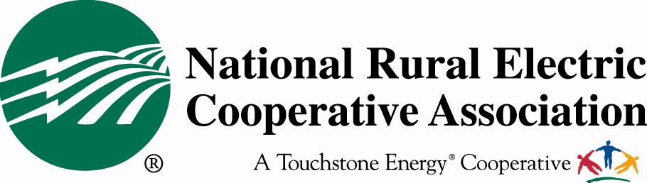

Electric Cooperative Issues in the 112th Congress

America’s not-for-profit electric cooperatives view all legislative issues from the perspective of affordability and reliability for their 42 million electric cooperative consumer-members. In the 112th Congress, NRECA and its more than 900 member electric cooperatives have legislative concerns across a wide range of issues.

RUS Appropriations: The Rural Utilities Service (RUS) Electric Loan Program is the type of public-private partnership government should be looking to right now in order to leverage taxpayer money. It allows us to leverage federal funds at virtually zero cost – to do more with less. This is lean, smart government.

- Cutting the Electric Loan Program would be an indirect tax on energy consumers. Rural electric co-ops that utilize this RUS program are not-for-profit utilities that sell most of their power to residential consumers. Should this program go away, the increased cost of doing business will end up hurting rural families. Without the Electric Loan Program, the cost of doing business for rural electric co-ops will certainly go up; that means higher electric bills for 42 million people. This rate increase would impact an estimated 1.8 million small businesses and farms. Now is the wrong time to tax Americans, especially in a way that will damage the heart of rural economies: agriculture and small business.

- Rural electric cooperatives are the least subsidized utilities within the electric utility sector. After calculating investment tax credits, accelerated depreciation, and other tax benefits to investor-owned utilities (IOUs), the for-profit utilities are subsidized about $34 per customer. Meanwhile, municipal-owned electric utilities issue tax-exempt bonds that result in a federal subsidy of about $55 per customer. Compare these figures to the Electric Loan Program, which has historically come at a very low cost and is currently making money for the federal government ($51 million in FY11).

Renewable Energy Incentives: Rural electric cooperatives are investing in renewable generation resources even though they are not yet cost competitive with conventional gas-fired generation. Since 2005, electric cooperatives have participated in the Clean Renewable Energy Bond (CREB) program which provides an incentive comparable to the Production Tax Credit and 1603 Treasury Grant program available to private developers that invest in renewable generation. Electric cooperatives have utilized all funding currently available for the CREB program. NRECA urges Congress to authorize an additional $3.2 billion in bonding authority for the program for electric cooperative and municipal utilities.

Renewable Electricity Standard: NRECA is opposed to a federal RES mandate that does not exempt all distribution cooperatives. NRECA also strongly believes that Congress should refrain from imposing any RES mandate until the issue of how to provide transmission to move the power to where it is needed is resolved. Without adequate transmission or a workable approach to solving the triple challenge of siting, planning and cost allocation, a RES will result in a back-door electricity tax and lead to other unacceptable costs for electric cooperative consumers.

Health Care: NRECA insists that any amendments to or repeal of the health care law must preserve each electric cooperative’s ability to tailor its employer provided health benefits package as currently allowed under the Employee Retirement Income Security Act (ERISA), which preempts state regulation of NRECA’s Group Benefits Trust.

Retirement: NRECA is focused on protecting its Retirement Security Plan from any Deficit Reduction Contribution (DRC) in 2012 or 2013 (approximately $300 million) to help electric co-ops avoid the impossible choice of increasing electricity rates, reducing or eliminating retirement benefits altogether or laying off quality employees to pay for massively inflated short-term liabilities.

Power Marketing Administrations: PMAs may be targeted by Congress or this Administration as a revenue-raiser (as recommended by the National Commission on Fiscal Responsibility and Reform). Since many electric cooperatives depend on federal power to provide affordable electricity to their member-owners, NRECA will fight to maintain their right to that power.

EPA Greenhouse Gas Regulations: NRECA believes the Clean Air Act (CAA) is ill-suited for controlling greenhouse gas (GHG) emissions. NRECA urges Congress to step in and prevent the Environmental Protection Agency (EPA) from using the CAA as a tool for reducing GHG emissions from stationary sources like power plants. Electric co-ops will support efforts in the 112th Congress to delay EPA regulation of GHGs under the CAA.

Coal Combustion Byproducts: EPA has proposed regulations for the management of Coal Combustion Byproducts (CCBs). NRECA is strongly opposed to regulating CCBs, including coal ash, as a hazardous waste under the Resource Conservation and Recovery Act (RCRA) and supports maintaining regulations under the non-hazardous provisions of RCRA. Under a hazardous designation, beneficial use of CCBs will be lost and companies will be forced to spend billions of dollars to dispose of CCBs at hazardous waste facilities.

Telecommunications: Electric cooperatives are watching to see how the new Congress will promote further deployment of broadband. NRECA will work to ensure that our interests in two important policy arenas are protected – pole attachments and spectrum allocation. We seek a continuation of the electric cooperative exemption from federal pole attachment regulation and we also want to ensure that electric cooperatives have the radio spectrum needed to provide an evolving smart grid and to ensure reliability of our systems.

Cybersecurity: NRECA cooperative members are committed to a reliable, secure electric power grid and take our responsibilities in this area very seriously. However, we do not believe that the Federal Energy Regulatory Commission needs additional authority to increase security of the grid. We look forward to working in a bipartisan manner with Congress to develop federal authority that can pull together the necessary elements of the federal government and the private sector quickly in the event of an extreme cyber emergency.

Brian Cavey, NRECA Legislative Affairs
703.907.5815
brian.cavey@nreca.coop

