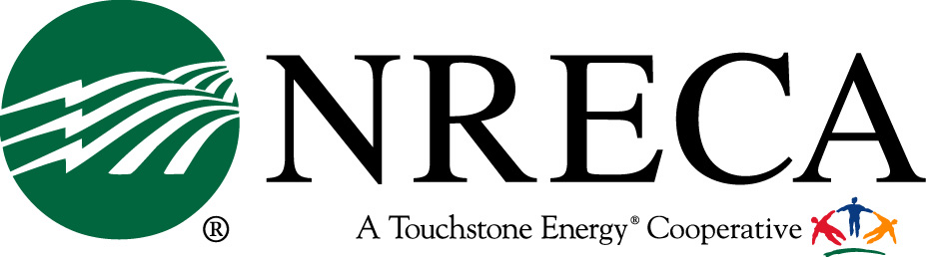
Contact: Tracy Warren • PH: 703.907.5746 • Cell: 703.517.3411 • email: tracy.warren@nreca.coop
NEWS
December 21, 2011
For Immediate Release:

Electric Co-ops Disappointed in the Administration’s Actions
On Utility MATS Rule

ARLINGTON, VIRGINIA – Glenn English, CEO of the National Rural Electric Cooperative Association (NRECA), on behalf of the nation’s 42 million electric cooperative consumer-members, expressed disappointment in the final Utility Mercury and Air Toxics Standards (Utility MATS) issued by the Environmental Protection Agency (EPA) today.

“NRECA urged the Administration to provide sufficient time to comply with the new rule’s requirements. While EPA indicates that they will “encourage states” to provide up to four years to comply and may, case by case grant additional time, electric cooperatives remain concerned that the Administration has chosen a path that only provides certainty to facilities if they comply within three years. This simply will not provide all facilities sufficient time to cost-effectively comply with the standards. Ultimately, consumers will bear these additional costs,” English warned.

Over the past month, NRECA met with Senior Administration officials at the Office of Management and Budget and at EPA to reiterate our concerns. In a letter to the Office of Management and Budget in November, NRECA expressed doubt the utility industry as a whole, and cooperatives in particular, could meet the new standards in three years. The deadline creates special problems for cooperatives. Often, small systems must compete with larger utilities for the limited number of engineering experts and equipment vendors – smaller systems stand at the back of the line.

“Electric cooperatives will comply with Utility MATS, but during the transition many co-ops will likely have to purchase power on the open market. As not-for-profit member-owned utilities, these higher prices are directly passed onto our members in their electric bills,” English said.

Cooperatives across the nation are installing advanced pollution controls. NRECA’s Cooperative Research Network has a portfolio of research projects on promising technologies that may provide lower-cost solutions. Greater flexibility would allow cooperatives to meet this and other new rules in a manner that could minimize the burden on the consumer.

NRECA will continue to work with the Administration to establish reasonable compliance timelines.

The National Rural Electric Cooperative Association is the national service organization that represents the nation’s more than 900 private, not-for-profit, consumer-owned electric cooperatives, which provide service to 42 million people in 47 states. .c

###

