TESTIMONY OF

JOHN PRESCOTT
PRESIDENT AND CEO
PNGC POWER

BEFORE THE
COMMITTEE ON NATURAL RESOURCES
SUBCOMMITTEE ON WATER AND POWER

U.S. HOUSE OF REPRESENTATIVES

HEARING ON
INVESTMENT IN SMALL HYDROPOWER:
PROSPECTS OF EXPANDING LOW-IMPACT AND AFFORDABLE HYDROPOWER GENERATION IN THE WEST

JULY 29, 2010

Testimony of John Prescott

United States House of Representatives
Committee on Natural Resources Committee, Subcommittee on Water and Power
Investment in Small Hydropower: Prospects of Expanding Low-Impact and Affordable Hydropower Generation in the West

July 29, 2010

- Introduction

Madam Chair and Members of the Subcommittee, I am John Prescott, President and CEO of PNGC Power. Thank you for the opportunity to testify before the Subcommittee today, and for holding this hearing on an important topic.

PNGC Power is a wholesale electric cooperative based in Portland, Oregon, with 16 rural electric distribution cooperative members serving retail electric customers in seven Western states. PNGC meets the power needs of our members with a combination of purchases from the Bonneville Power Administration, renewable resources, and market purchases. We also manage the transmission needs of our members.

I have 28 years of experience in power management and operations in the energy industry. Prior to my current position at PNGC Power, I served as the Power Supply & Environmental Affairs Officer at Seattle City Light, a large municipal utility in Seattle, Washington, and as the vice-president of Power Supply of the Idaho Power Company, an investor-owned utility located in Boise, Idaho. I am a registered Professional Engineer in eight western states. I currently serve on the Member Representatives Committee of the North American Electric Reliability Corporation (NERC), and the Power and Generation Committee of the National Rural Electric Cooperative Association (NRECA).

My testimony today will touch on low-impact hydropower and the Federal Columbia River Power System (FCRPS). However, most of my testimony will focus on the challenges of integrating increasing amounts of wind energy into our mainly hydro-based power system in the Pacific Northwest.

I would like to take this opportunity to thank the members of the Subcommittee from the Northwest for their strong and ongoing support of the FCRPS. Representatives Hastings, DeFazio, Inslee, and McMorris Rodgers, we appreciate your work on behalf of all who benefit from this valuable system.

- Low-Impact Hydropower

First, PNGC Power supports low-impact hydropower development. In fact, one of PNGC Power’s distribution cooperative members, Fall River Electric Cooperative, is completing an innovative hydro project in Idaho, the Chester Hydro project on the Henry’s Fork of the Snake River. PNGC fully supports small hydropower development.

- The Federal Columbia River Power System

While we support small scale, low-impact hydropower, it is the large, Federally-owned dams in the Columbia River Basin that provide most of the electricity needs of PNGC Power’s members. Since President Roosevelt inaugurated the system with the Bonneville Dam, the Bonneville Power Administration (BPA) has marketed the output of the FCRPS dams as a renewable, affordable and reliable source of electricity for people across the Northwest. PNGC Power and its members will continue to rely on the power from the Federal dams for years to come.

The FCRPS has faced increasing challenges in recent years due to efforts to protect and enhance endangered species, increasing electricity demand in the region, and the integration of increasing amounts of wind generation. Bonneville Power’s customers have worked closely and in good faith with Federal, State and Tribal partners to meet these challenges. The FCRPS continues to be a valuable and flexible renewable resource, and as the Members of this Subcommittee know, its benefits extend well beyond the Northwest.

- The Challenges of Wind Integration

Wind is an important part of our changing energy portfolio. Wind generation’s carbon-free fuel can displace other carbon-producing fuels reducing the carbon used in electric energy generation. Significant financial incentives for wind generation exist at both the state and Federal levels. However, the physical characteristics of wind, large and swift variability within the hour and between hours and an inability to dispatch wind generation when it is needed, pose challenges to the existing electric utility structure.

We cannot realize the full value of wind generation in the Pacific Northwest unless we adequately address what might be the single largest issue facing the system today: integration of energy from wind. In the remainder of my testimony I will discuss the challenges with integrating increasing amounts of wind into the BPA system, the important steps that BPA has taken to date to address these challenges, and some of the factors that are increasing the costs of wind integration.

- Wind Generation and the BPA System

Wind Saturation: The area in which the BPA is responsible for balancing electricity generation and consumption, called the Bonneville Balancing Authority, or BPA BA, has a very high saturation of wind generation. As an example, BPA’s BA demand this month (July, 2010) has varied from between 5,000 MW and 6,800 MW. In the BPA BA today there is 2,836 MW of installed wind generation, producing between zero and full output throughout the month. BPA expects to have 6,000 MW of wind generation in its BA by 2013.

This high saturation of wind exacerbates the difficulties of integrating wind into the system: 1) the very limited capacity value of wind generation in extreme weather conditions, i.e. a lack of ability to rely on the wind resource to meet peak loads, 2) wind’s variable generating output both within each hour and between hours, and 3) the inability to schedule wind accurately.

Capacity Value: During periods of sustained high demand for electricity in the Pacific Northwest, caused by either hot or cold weather, the wind tends not to blow. In other words, there is very limited capacity value to wind when electricity demand is the highest. Wind blows because of temperature or pressure differentials. In extreme weather, there is often little temperature variation across a wide area (Arctic Express or scorching temps across a large part of the region) or little pressure differential (pervasive low or high pressure systems). This dilemma is illustrated in the two figures below.

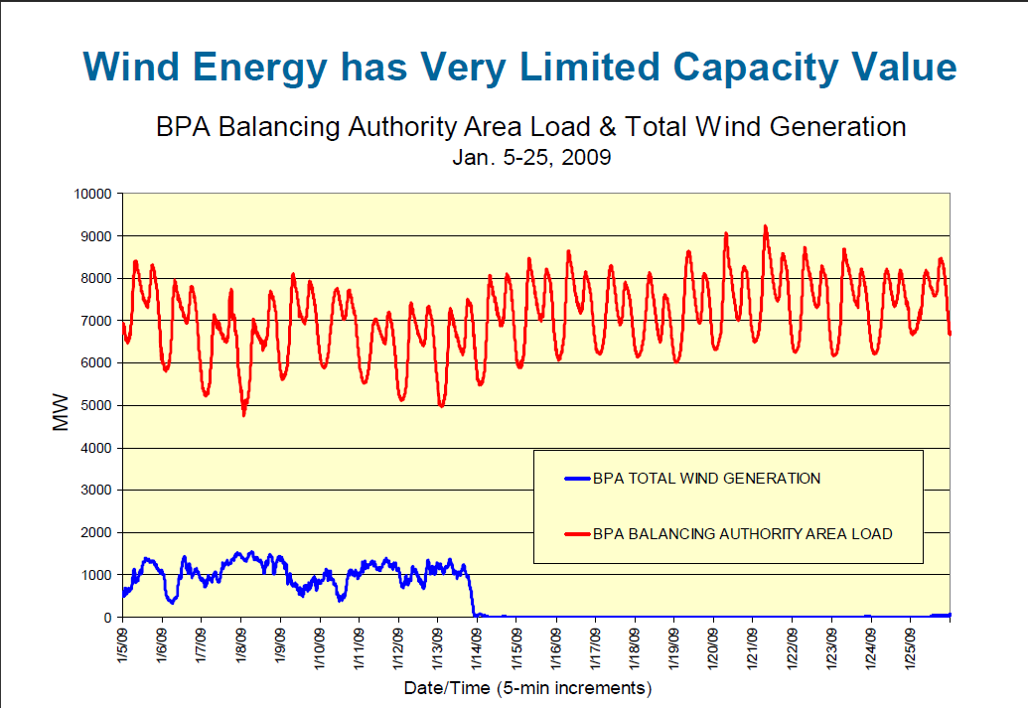

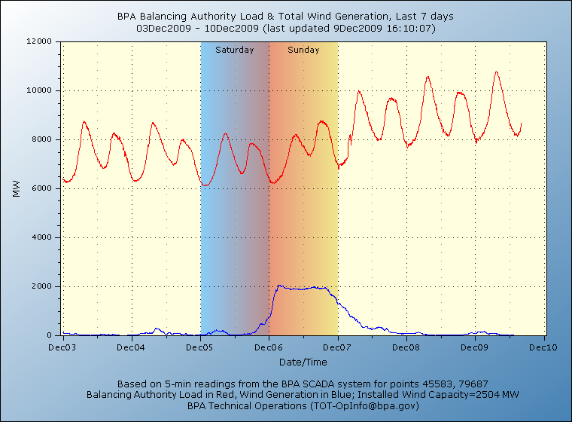

Generation Response Issues: Since the demand for electricity and resources must be balanced at all times in an electrical system, when wind generation ramps up or falls off quickly the BA operator must just as quickly bring up or drop off other generation sources. Currently, in the BPA BA wind generation can vary by as much as 1,000 MW in less than an hour. The BPA BA operator must have enough additional generation that is dispatchable to balance the system. This ability to quickly change generation levels is called a ramp and the speed with which you can change a generator is called the ramp rate. Although hydro is among the best resources for ramping, even hydro resources have ramp rate limitations. Specifically in the Northwest, the Federal dams have operating criteria and ramping limits imposed on the individual projects and on overall river operations by irrigation, navigation, fish mitigation management, and recreation. Thus, as more variable wind generation comes onto the BPA system, BPA must manage the multitude of competing uses and hold an increasing amount of hydro in reserve to maintain the reliability of the system. Reliability of the system is an imperative that can not be compromised.

The graph below demonstrates wind’s variability over a short period of time.

Cost of Reserves: As more of the hydro system is held in reserve to deal with the variability of wind generation, there are several places where BPA’s other customers can be impacted. First, as hydro is held aside for reserves, it can not be used to serve BPA customer loads thus requiring other sources of generation. Second, the hydro system has reduced flexibility which increases the cost to BPA of being responsive to other constraints being placed on the system, such as required operations for salmon and steelhead recovery, and other purposes such as irrigation, navigation and recreation for which the federal projects were authorized by Congress.

Geographic Concentration of Wind Generation in the BPA Balancing Authority: The majority of planned and existing wind generation in the BPA BA is in the Columbia Gorge. (See figure below.) This concentration of wind generation has outstripped the BPA transmission system ability to move all of the existing and projected wind power. New transmission is needed and has been planned by BPA to help integrate wind generation from the Columbia River Gorge and to meet other transmission requests. Other wind locations provide additional transmission challenges. Cost allocation and use of BPA’s borrowing authority for additional transmission for wind are the key issues for BPA’s customers.

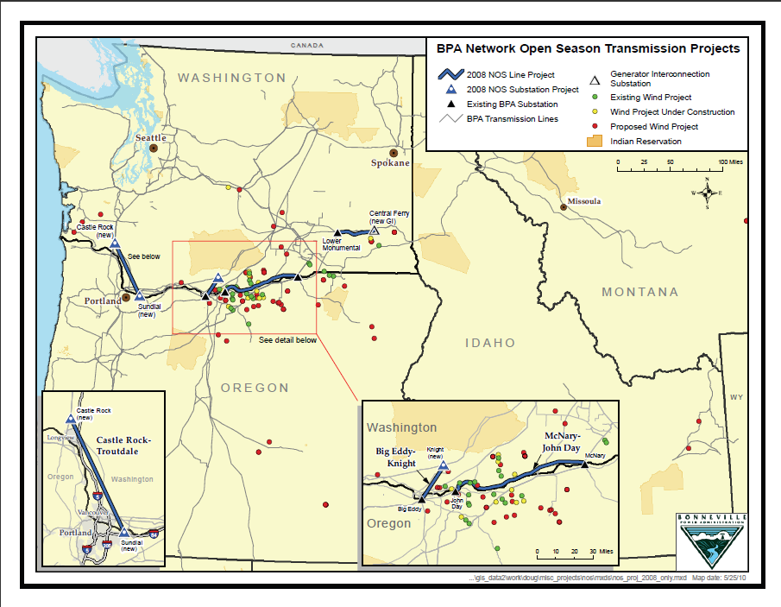

- Bonneville’s Steps to Address The Challenges of Wind Integration

To the credit of the agency, BPA has taken some excellent steps in addressing the enormous challenges of wind integration. The Administrator and his staff are working to address these issues. BPA has set aside reserves and established associated operating orders, installed new wind measurement devices, undergone important technical studies, and instituted new scheduling techniques.

- Reserves and Reliability Protocols

The primary means of addressing the variability of wind generation is to set aside the appropriate amount of generating reserves. If wind drops off within an hour, BPA stands ready to supply that amount of dropped generation. If wind comes up quickly within an hour, BPA must be able to ramp down other generation. BPA sets aside reserves of generating capacity to deal with these within hour conditions. The appropriate amount and cost of these reserves has been and will continue to be an issue.

If BPA’s use of reserves exceeds 90%, BPA operators use established reliability protocols that will 1) in the case of wind dropping off suddenly, require wind generators to reduce their schedule to reflect the physical reality, or 2) in the case of wind generation increasing suddenly, require wind generators to reduce the wind generation output down to the scheduled amount. Use of these reliability protocol orders by the BPA system operators is an important tool to maintain system stability and to prevent a situation that could lead to cascading outages.

- Other BPA Wind Initiatives
  - Improving Scheduling Accuracy of Wind
BPA has installed 14 new wind measurement devices and shares the real-time wind data with BPA system operators and with wind operators. This helps BPA and the wind generators schedule more accurately and anticipate large changes in wind generation levels allowing system operators to better and more reliably set up and run the system.

  - Dynamic Transfer
BPA is now dynamically transferring wind generation into other Balancing Authorities. Dynamic transfer uses transmission capacity and electronic signaling to make generation appear to be in another BA thus shifting the burden of reserves to the receiving BA. Because 80 percent of the wind generation in BPA’s BA is exported to other BAs, dynamic transfer lowers the burden of wind balancing on BPA.

  - Intra-Hour Scheduling
Currently, power is scheduled for an hour. However wind generation can vary significantly within an hour. BPA has developed tools to allow wind generators to change their schedules at the half-hour. Intra-hour scheduling reduces the amount of reserves BPA must carry for wind generation and allows BPA to have better information for reliability of the system.

- Transmission

BPA has undertaken a very successful effort to address its long transmission request queue, of which many request are from wind generators. In a process called Network Open Season (NOS), begun in 2008, BPA simultaneously offered transmission service to all requests in its transmission request queue. For all customers who choose to move forward with their transmission requests, BPA studies those requests together, in a cluster study, to determine the combined impact on the BPA transmission system. If the needed transmission can be added with minimal rate impacts, BPA may agree to build the needed expansions at rolled-in transmission rates, instead of charging the transmission additions just to the requesting customers.

As a result of this NOS process, BPA is proceeding with four major transmission expansion projects. One of these projects is under construction (McNary - John Day) and three others are in NEPA review. The additional transmission capacity will do much to improve the free flow of power throughout the system as well as to integrate additional wind generation.

The NOS process is repeated annually. We support BPA’s approach to dealing with its transmission queue by using NOS, to its approach to how costs are allocated for additions under NOS, and with its repeatable NOS process. BPA’s willingness to study the combined impacts of multiple transmission requests has resulted in much needed transmission expansion.

- The Increasing Costs of Wind Integration

These strong steps that BPA has taken come at a cost. PNGC believes it is critical that these costs be borne by those who buy and sell wind generation. With over 80 percent of the wind generation in BPA’s BA being exported to customers outside of the BA, cost mechanisms for reserves and transmission that do not burden BPA’s public power customers and pass the costs of wind integration onto those who are developing or buying the wind generation is vitally important.

The level of reserves held for balancing wind generation and who should pay that cost is a major issue. Without adequate reserves, system reliability is threatened and system operators must curtail the wind generation or wind schedules more frequently. Higher levels of reserves draw the question of who should pay for those reserves into sharp focus. The reduction of Federal hydropower due to its use for wind reserves also means that BPA’s public power customers have less power available and new generation resources must be developed to fill this hole. These new resources, that would not otherwise need to be developed, ultimately increase the cost of power to Northwest retail consumers.

We support BPA’s implementation of a Wind Balancing Service which charges wind generators for within-hour reserves. However, if the projected level of wind generation becomes a reality, up to 6,000 MW by 2013, we must continue to develop more innovative solutions and fair cost allocation mechanisms to deal with the increasing burden this new generation will put on the BPA system. We are committed to work towards solutions that allow wind generation to serve load without jeopardizing reliability and with the proper allocation of costs.

It is critical that we accurately reflect the costs of wind integration in the price of wind energy. Doing so makes the real cost of wind more transparent to buyers. This puts wind on a more level playing field with other renewable generation and stimulates research and development into new technologies such as energy storage. If we hide the true cost of wind, we are perhaps missing, as a society, other more cost effective renewable resources. Transparent pricing of wind integration services also encourages wind generators to make investments in technology to forecast the wind more accurately.

- Conclusion

In conclusion, I want to leave you with a reminder that PNGC Power strongly supports the development of renewable resources. In fact, we are proud to receive most of our electricity from hydropower, the number one renewable source of electricity serving customers today. In that vein, we must also recognize the true costs of wind integration. If wind integration is done right, we can continue to successfully add additional renewable energy to the nation’s power supply. At the same time, we must not degrade the reliability of the power system, and we must ensure that wind integration costs are properly allocated.

Madam Chair and Members of the Subcommittee, thank you again for the opportunity to testify at this hearing. Small hydro development and wind integration are both critically important topics, and I thank the Subcommittee for allowing me to participate in this discussion.

Source: http://www.transmission.bpa.gov/Business/Operations/Wind/baltwg.aspx
Source: Projected Wind Projects Connected to BPA Grid based on Existing Queue and Recent Trends, http://www.transmission.bpa.gov/PlanProj/Wind/documents/BPA_Wind_Forecast_Graph_2016.pdf
BPA’s 2009 Draft Resource Program, http://www.bpa.gov/power/P/ResourceProgram/documents/2009-09-30_DraftResourceProgram.pdf From section 6.3.5, Wind, page 55: “The Council’s draft Sixth Power Plan assigns a 5 percent value to wind in terms of providing capacity to meet peak loads. However, recent studies correlating wind speed and load patterns show that the wind in the Columbia Basin tends to die down and remain calm during sustained peak load periods such as hot spells and cold snaps.”
Source: http://www.bpa.gov/corporate/WindPower/docs/Wind-WIT_generic_slide_set_Sep_2009_customer.pdf
http://www.bpa.gov/corporate/WindPower/docs/Mainzer_BPA_FinalTestimonyforSenate121009.pdf
http://www.transmission.bpa.gov/Customer_Forums/open_season_2009/2008_nos_Summary_Timeline_Map.pdf

