***EDITORIAL NOTE:*** *The Straight Talk team received several requests for a customizable article about the recent executive order calling for review of the Clean Power Plan.**Please feel free to personalize this article for your co-op/PUD/PPD. Questions? E-mail* [StraightTalk@nreca.coop](mailto:StraightTalk@nreca.coop)*.*

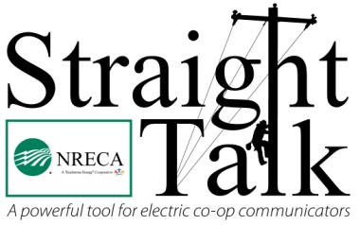

*NRECA’s* Straight Talk

*April 2017*

*Words: 320*

**New executive order calls for review of the Clean Power Plan**

*By Dan Riedinger*

Throughout the 2016 campaign, Donald Trump pledged to review burdensome federal regulations when he became president. On March 28, President Trump took an important step to follow through on that commitment by signing an executive order to promote energy independence. The order also calls for review of the Clean Power Plan.

“Electric co-ops have two key missions—providing electricity and other services to more than 42 million consumers and empowering the communities they serve,” said Jim Matheson, chief executive officer at the National Rural Electric Cooperative Association (NRECA), the national service organization for the nation’s more than 900 electric co-ops. “The Clean Power Plan jeopardizes co-ops’ ability to accomplish both.”

“If implemented, the plan would hit many of our electric cooperatives extremely hard by forcing them to prematurely shut down existing power plants. Those co-ops would in essence be charged twice for their electricity—once to continue paying down the loans on the closed power plants and again for the cost of purchasing replacement power,” he said.

Co-ops were so concerned about the economic impacts of the Clean Power Plan that they petitioned the courts to review and reject the regulation. The Supreme Court sided with co-ops and imposed a stay of the rule—essentially freezing its implementation. This pause created the Trump administration’s opportunity to review the rule.

Electric co-ops put the interests of their members first when deciding how to best meet their energy needs. The Trump executive order allows co-ops to continue reducing their carbon footprint while keeping traditional energy resources in the mix. This is critical as co-ops work to preserve both the reliability and affordability of electricity.

It will take the Trump administration a long time to navigate the maze of administrative, regulatory and legal procedures necessary to review the Clean Power Plan. In the meantime, electric co-ops will keep doing what they do best—delivering a consumer-focused energy future that empowers cooperative members and their communities.

*Dan Riedinger writes on consumer and cooperative affairs for the National Rural*

*Electric Cooperative Association, the Arlington, Va.-based service arm of the nation’s*

*900-plus consumer-owned, not-for-profit electric cooperatives.*

###