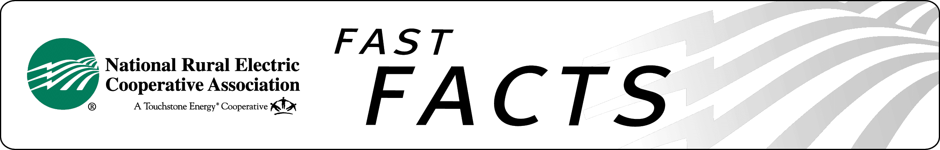

Stop PBGC From
Grossly Overcharging Co-op & Charity Pension Plans

PASS the “Retirement Enhancement and Savings Act of 2016”
(Unanimously Passed by the Senate Finance Committee on 9/21/16)

Issue. Over 880 rural electric cooperatives participate in the defined-benefit “multiple-employer” pension plan sponsored by NRECA, covering over 56,000 employees in 47 states. Co-op employees are the backbone of our core mission to provide, safe, affordable, and reliable electricity. But rules designed for other types of pension plans were increasing volatility and cost pressures on participating cooperatives.

Status. In 2014 Congress passed a law recognizing that – by our nature – we pose virtually no risk of default to the Pension benefit Guaranty Corporation (PBGC), and yet we continue to pay insurance premiums as if we were such a risk. (See Cooperative and Small Employer Charity Pension Flexibility Act of 2014 (Pub. L. No. 113-97) (“CSEC”). Current PBGC rules designed for “single-employer” for-profit companies inappropriately require us to divert scarce resources from our core mission. The “Retirement Enhancement and Savings Act of 2016”, unanimously passed by the Senate Finance Committee on September 21, 2016, fixes this inequity permanently.

NRECA Position. Congress should pass this legislation immediately. The same facts that led Congress to adjust funding rules for CSEC plans strongly support adjusting PBGC premiums charged to CSEC plans like the ous. Since CSEC plans pose far less risk to PBGC than “single-employer” plans, it does not make sense for CSEC plans to be subject to that premium structure. It’s time to stop forcing charities and not-for-profit cooperatives from subsidizing the PBGC premiums of “single-employer” for-profit companies. PBGC’s own data supports reducing premiums for CSEC plans; in fact, PBGC projects making more than a 3,000% return on CSEC plans for the 2014-2018 period. This legislation is also endorsed by Girl Scouts of the USA; Boy Scouts of America; Christian Schools International; The Jewish Federations of North America; UJA, United Jewish Appeal, Federation of New York; National Council of Farmer Cooperatives; NTCA - The Rural Broadband Association; United Benefits Group, and Hawkeye Insurance Association.

for more information
Chris Stephen, NRECA
703.907.6026
chris.stephen@nreca.coop
http://www.nreca.coop

