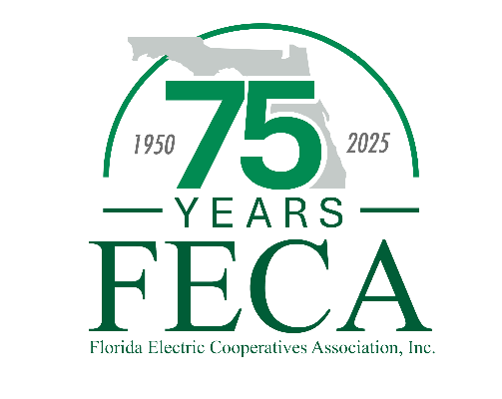
2025 Storm Preparedness Workshop
Hilton Ocala (3600 SW 36th Ave)
Arlington Room
May 21 - 22, 2025

Agenda

Wednesday, May 21

01:00 PM Welcome and Introduction Alisia Hounshell, FECA

01:30 PM Basecamp Logistics Robb Brown & Todd Fountain, Duke Energy

02:20 PM Basecamp Trailer Options Megan, Renee, & Anthony Kelly, Kelly & Co.

02:30 PM Break & Visit

03:00 PM Basecamps Lessons Learned Ben Dawson & April Brown, SECO Energy
(co-op personnel only) Frank Tomkow, WREC

03:30 PM Working with Your Local EOC Preston Bowlin, Director Marion Co. EOC

04:00 PM Break

04:15 PM Storm Leadership Training Allan Ruth, LCEC

05:00 PM Adjourn

Thursday, May 22

08:30 AM Statewide & Federal Uncertainties Allison Carter & Forrest Boone, FECA
(co-op personnel only)

09:00 AM Hurricanes, Tornadoes, & Ice, Snoh my! Ryan Campbell, EREC & Mike Grice, Talquin
(co-op personnel only)

09:45 AM Break

10:00 AM FEMA Panel Anh Reynolds & Chris Petersen, SECO
(co-op personnel only) Lisa Burnett, Talquin
Christine Moore (CFC, formerly SVEC)

10:45 AM Break

11:00 AM Storm Manager Mutual Aid Resource Richard Addotta, Urbint

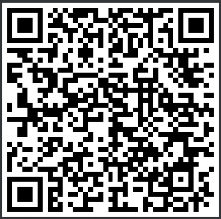
12:30 PM Adjourn

We value your feedback!
Please complete this brief survey.
2025 Attendee List

Central FL EC
Shelby Allen
Jim Beauchamp
Carmen Beauchamp
Daniel Powell

CHELCO
Kevin Wilkerson
Robin Shaw

Clay EC
Bryan Gunter
Clint Sheppard
Chris Bryan

Escambia River EC
Ryan Campbell
Sonya Dooley
Crystal George

Florida Keys EC
Peter Amendola
Nick Lyons

Glades EC
Colin Evans
Wesley Sims
Ken Tripp
Robert Hall
Mandy Cruz

Gulf Coast EC
Tress Dameron
Angie Morris

LCEC
Allan Ruth
Rusty Snider
Benjamin Escobar
Karen Vivian
Lisa Orr
Michael Bates
Allan Wagner
Varlam Molina

Okefenoke REMC
David Smith
Travis Page
Eric Dyal

Peace River EC
Randy Shaw
Van Crawford
Paul Roberts
Jamie Fones
Teresa Hamilton

SECO Energy
Ben Dawson
Travis Walton
Tim Wallace
Kathy Posso
Chris Petersen
Anh Reynolds
Amy Pruett
Sarah Springer
Tracey Scotto
Todd Brown
Karen Kunik
Melinda Ferguson
April Brown
Wayne Pennington
Hank Bolduc
Tolu Omotoso
Juliana Puerta

Seminole EC
Charles Wubbena
Greg McAuley

Suwannee Valley EC
Mike McWaters
Crystal Ecker
Trevor Touchton
Scott Sheffield

Talquin EC
Mike Temple
Mike Grice
Terrance Roberts
Lori Pilz
Lisa Burnett
Byon Smiddy

Tri-County EC
Jeff Brewer
John Tuten

West FL EC
Wayne Williams
Penny Bryan
Seleta Mason
Holley Brown
Sharon Curry
Will Melton

Withlacoochee River EC
Ben Cooper
Greg Sibley
John McCarty
Randy Tolle
Amber Miller
Kevin Weigeshoff
Ricky Gude
Kevin Hayes
Richard Stone
Frank Tomkow
Ricky Groover
Kris Walzak

FECA & Guests
Mike Bjorklund
Allison Carter
Alisia Hounshell
Jeff Banka
Drew Love
Forrest Boone
Christine Moor, CFC
Gerald Gordon, Electric Cooperatives of Mississippi

