December 31, 2024

The Honorable Ben Albritton

State of Florida State Senate

Room 330 Senate Building

404 South Monroe Street

Tallahassee, FL 32399-1100

Dear Senator Albritton,

Florida’s electric cooperatives invite you, your family, and your legislative staff to a Legislative Appreciation Cookout to be held Tuesday, March 18, 2025, at the Goodwood Museum & Gardens Carriage House Conference Center, 1600 Miccosukee Road, Tallahassee, Florida (map and directions are provided on the back of the enclosed invitation).

Join us and sample the taste of Rural Florida: everything from beef and pork tenderloin, conch fritters, chowder, chicken wings, shrimp, desserts, and various other tasty selections.

We look forward to visiting with you.

Sincerely,

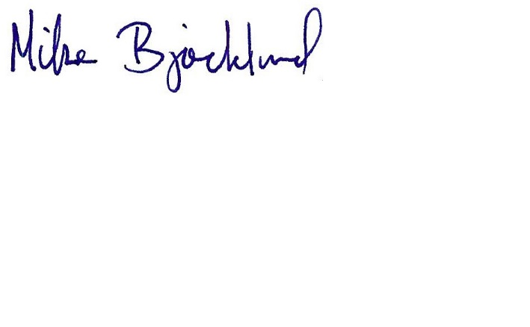

Mike Bjorklund

General Manager

MB/ea

FECA

**Note:** The provisions of Florida Statutes 11.045 and 112.3215 prohibit members of the Legislature, agency officials, their spouses and any guests who are paid employees of such person, from accepting complimentary admissions or gifts. For this reason a charge of $15 has been established to defray the cost of the meal and a collection table will be provided for those affected by the statutes.