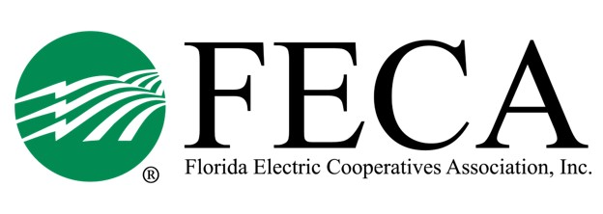
2025 Lobby Clinic
FECA (2916 Apalachee Pkwy, TLH)

AGENDA

Monday, January 13
11:30 PM Lunch available
12:00 PM Welcome/Safety/Attendee Intro Drew Love/Alisia Hounshell
12:15 PM DC Overview Michael Nolan
01:30 PM Break
01:45 PM VCP Campaign Allison Carter
02:15 PM America’s Electric Co-op PAC Drew Love
02:30 PM Break
03:00 PM Why We Lobby? Rep. Danny Alvarez, HD 69
04:00 PM Adjourn
05:00 PM Optional Social Hour Casa Tapas & Cantina

Tuesday, January 14
*breakfast available at hotel*
08:30 AM Statewide Synopsis Drew Love
09:15 AM Minimum Time, Maximum Impact Jamie Fones, Ashleigh Hayes PRECO
10:00 AM Break
10:15 AM PSC Update/IOU Rates Forrest Boone
11:00 AM Open Discussion/Announcements Group/FECA
11:15 AM Adjourn

