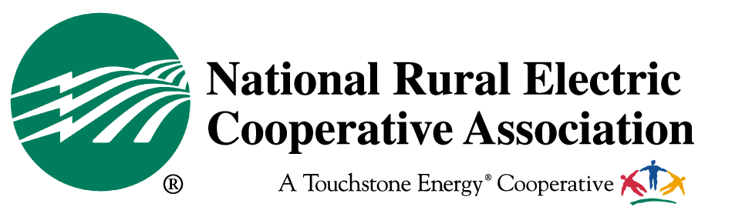

August 2012 Recess Pocket Card
* * * * * * * * * * * * * * * * * * * * * * * * * * * * * *
Recess offers a special opportunity that arrives every 2 years. You have the opportunity to talk to members in your Congressional Delegation while they are paying their closest attention - right before the election. And we need their help on a couple of tough issues. So, help us make the most of this opportunity to advocate on behalf of the needs of electric cooperatives.

First of all, the Coal Ash Legislation is still active and has received a recent burst of activity. On August 1, the Senate re-introduced legislation to prevent the EPA from regulating Coal Ash as hazardous. As you know, over 40% of coal ash generated finds its way into beneficial uses from concrete roadways and drywall to bowling balls and cement. This compromise language was negotiated in the final deliberations on the Surface Transportation Reauthorization Conference. With twelve Democratic Co-sponsors to date, we are very close to getting a number that demonstrates we can achieve 60 votes on the bill. If your senator is one of the co-sponsors, please thank them during the Recess. If your Senator is not yet a co-sponsor, check with their in-state office to find out when they will be in your service territory. Make a point to attend. Encourage others to join you.

- Ask your member, especially Democrats, to co-sponsor this bill; and

- Ask all Senators to support this bill when it makes its way to the floor of the Senate.

With the Farm Bill, the path of a 5-year reauthorization is uncertain. The Senate passed S. 3240, on June 21. The House Agriculture Committee reported its bill, H.R. 6033, on July 11. While the bills differ significantly, both versions contain important provisions for electric cooperatives. Each authorizes a voluntary, on-bill financing program for energy efficiency improvements for electric co-op consumer-members, and reauthorizes a study of the impacts of rail monopolies on the economy of rural America. Additionally, the House bill includes a provision clarifying that RUS borrowers are not required to conduct costly environmental reviews for paper transactions such as lien accommodations. The bill also authorizes RUS lending for baseload generation. Now we need action in the House to allow a 5-year Farm Bill to move forward. A short-term extension would wipe out all the Farm Bill gains we’ve made in the House and Senate.

- Urge your Member of Congress to call on Speaker Boehner and Majority Leader Cantor to bring the Farm Bill to the floor; and

- Urge your Member of Congress to support a 5 year farm bill.

Electric co-ops with significant bulk electric system assets have been subject to mandatory, enforceable cybersecurity standards for seven years. Multiple bills seek to add yet more regulation, potentially extending oversight to distribution systems. Your Members of Congress should understand that the electric co-ops are already making significant efforts on cyber security and that any new legislation should maintain our current cybersecurity regulatory regime.

- Offer to work with your G&T to provide your Member of Congress a tour of their control room;

- Ask your lawmakers if you or NRECA can provide any additional material for them on this important and complicated issue;

- Inform your lawmakers that NRECA opposed S. 3414, the Cybersecurity Act of 2012, but want to work with Congress on legislation that improves cybersecurity, while maintaining the current standards process for electric utilities.

