FLORIDA ELECTRIC COOPERATIVES CHALLENGE

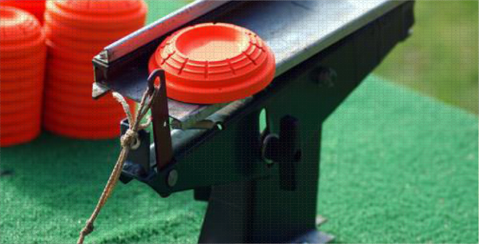

SPORTING CLAYS TOURNAMENT

# TEAM REGISTRATION INDIVIDUAL REGISTRATION SPONSOR REGISTRATION

## Name:

Address:

Company Name:

Phone:

Email:

INDIVIDUAL $75

TEAM $300 1.

2.

3.

4.

GOLD SPONSOR $500 **(INCLUDES 1 FOUR MAN TEAM REGISTRATION)**

### STATION SIGN, RECOGNITION DURING LUNCH

LUNCH SPONSOR $400 **INCLUDES STATION SIGN AND RECONGNITION**

**DURING LUNCH**

STATION SPONSOR $100 **(INCLUDES SIGN AT STATION)**

**FOUR PERSON TEAMS – 100 TARGETS – LOW SCORE DROPPED – NSCA RULES**

### OPEN TO ANYONE

Make Checks Payable to Bradford Sportsman’s Farm, Attn: Baynard Ward PO Box 160 Live Oak, FL 32064

# For more information, contact Baynard Ward, (386) 209-7410 or baynardw@svec-coop.com

# Derick Thomas, (386) 623-5333 or [dthomas@clayelectric.com](mailto:dthomas@clayelectric.com)

# Bradford Sportsman’s Farm is Located at 106th Ave., Graham, FL 32042, www.bsfshootingsports.com

Contributions to Bradford Sportsman’s Farm are not deductible for federal income tax purposes Net proceeds from this event will be deposited into the Florida ACRE Political Committee.

Employer: Occupation: