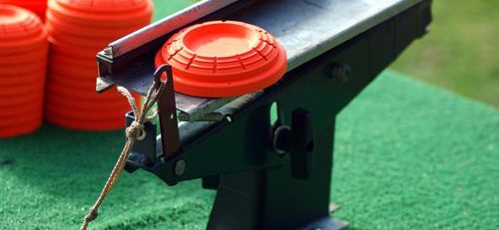

**May 29th**

**1PM**

FLORIDA ELECTRIC COOPERATIVES CHALLENGE

SPORTING CLAYS TOURNAMENT

OPEN TO ANYONE

$75 Per Person - $300 (4) Four Man Team

**All Net Proceeds go to the Florida ACRE Political Committee**

**FOUR PERSON TEAMS-100 TARGETS-LOW SCORE DROPPED-NSCA RULES**

Bradford Sportsman’s Farm, 11394 S.W. 106th Ave., Graham, FL 32042, www.bsfshootingsports.com

FOR MORE INFORMATION, CONTACT: Baynard Ward, (386) 209-7410 or [baynardw@svec-coop.com](mailto:baynardw@svec-coop.com)

Derick Thomas, (386) 623-5333 or [dthomas@clayelectric.com](mailto:dthomas@clayelectric.com)

Contributions to Bradford Sportsman’s Farm are not deductible for federal income tax purposes. Net proceeds from this event will be deposited into the Florida ACRE Political Committee.

Employer: Occupation: