**Article Title**: Co-ops Prepare for Hurricane Season

**Use:** Internal and/or External

**Photos:** We have a few photos that can be used in your newsletters and/or on your social media pages. This Dropbox folder will be available for 30 days. <https://www.dropbox.com/scl/fo/qsoir45npfbdj311ixrti/ABrtBAHCHtL0aSHWUJLat9U?rlkey=t7itx0ugm4xegupafqh9r1lx9&dl=0>

Each year, Florida’s 18 electric co-ops gather in Ocala at a meeting organized by the Florida Electric Cooperatives Association, to discuss the upcoming hurricane season. This year was no different, and with meteorologists predicting 2024 to be an extremely active season, attendees are laser-focused on storm preparation.

As Floridians are well aware, each storm has its own unique set of challenges. Event attendees heard from Tri-County Electric Co-op and Suwannee Valley Electric Co-op staff about their challenges and lessons learned from Hurricane Idalia that hit in 2023. By sharing their experience, these co-ops are helping their sister co-ops discover ways of improving upon their ever-evolving plans.

“By failing to prepare, you are preparing to fail.” – Benjamin Franklin

Like many Floridians, during storm season, electric co-ops are constantly watching different news and weather sources for the most up-to-date information. At this year’s meeting, we were joined by Mike Boylan, from Mike’s Weather Page. Mike shared his experience, expertise, and humor to show how we can best “unravel the spaghetti” and understand the different forecasting models. It is not a perfect science, but the more we know, the better prepared we can be.

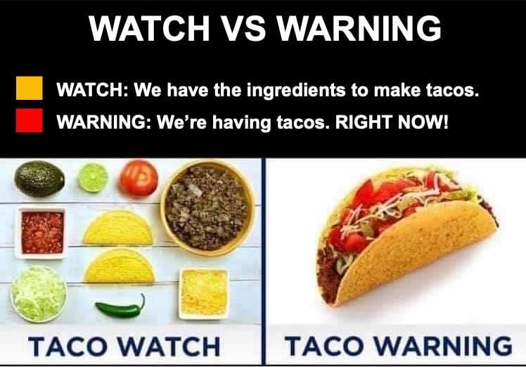

[*you can probably find a better image out there to share, but this is one of the fun examples Mike Boylan shared and it is an easy way to explain it to our members]*

Attendees also heard from the Florida Highway Patrol’s (FHP) Emergency Operations Coordinator, Capt. Derrick Rahming, Sr. Electric co-ops, and other electric utilities, rely on FHP and other law enforcement for assistance during any natural disaster. They assist with mutual aid escorts, traffic flow around basecamps and job sites, and other missions that co-ops may need. We thank Capt. Rahming for his commitment to our communities and for our continued partnership.

[*insert quote from co-op attendee, if wanted*]

Co-ops work together each year to prepare the unknown. The only certainty is that in the event of a crisis, electric co-ops across Florida will work together to get power restored as safely and quickly as possible.

[*insert photo of attendees touring basecamp trailers]*

Pictured above: Co-op attendees touring base camp sleeper, shower, and kitchen trailers brought by Storm Services.