**Rules on Collecting Contributions**

* Eligible individuals may use payroll deduction, personal check, credit card or cash
* 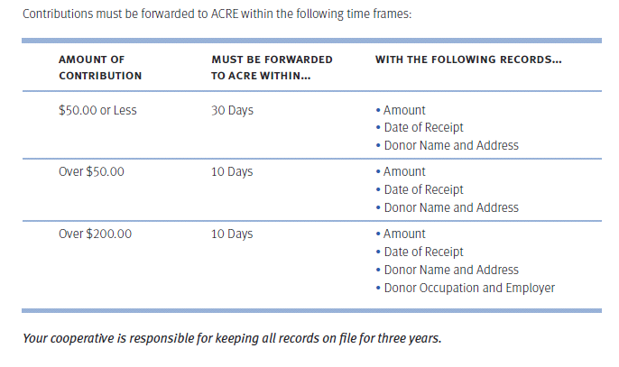Cash contributions cannot exceed $100.00 per individual

**How to Handle Contributions to ACRE®**

Once the contributions are collected, your cooperative may use two procedures to transmit ACRE contributions to NRECA or your state association. To send directly to NRECA at the ACRE Lockbox:

**ACRE**  
**P.O. Box 758778**  
**Baltimore, MD 21275-8778**

**Deposit Contributions into a Transmittal Account**

* This account can be set up solely for the deposit and transmittal of contributions collected on behalf of ACRE.
* The only disbursements that may be made out of this account are those that cover the sum of the month’s ACRE contributions.
* Any other expenditure made from this account turns the account into a depository of ACRE and all activities will have to be reported to the FEC.

**Deposit Contributions into the Cooperative’s Treasury Account**

* Contributions to ACRE may be temporarily deposited into the co-op’s treasury account.
* Your co-op must keep separate records for every deposit containing ACRE contributions.
  + Records should include the amount of the contribution, the date of receipt, and the name and address of the source.
* All cash contributions (up to $100.00) must be deposited separately so that separate deposit slips can be filed.