July 10, 2012

Dear Chairman Lucas and Ranking Member Peterson:

On behalf of the National Rural Electric Cooperative Association (NRECA), I write to express strong support for the Federal Agriculture Reform and Risk Management Act that will be considered by the House Committee on Agriculture on July 11, 2012. I would also like to express my sincere thanks to you both for your leadership on agriculture and rural development policy. On behalf of over 7 million electric cooperative consumer-members represented by members of this Committee, let me express my appreciation for your efforts to ensure critical advancements are made in rural America.

NRECA is the national service organization representing over 900 not-for-profit, member-owned, rural electric cooperative systems, which serve 42 million customers in 47 states. NRECA estimates that cooperatives own and maintain 2.5 million miles or 42 percent of the nation’s electric distribution lines covering three-quarters of the nation’s landmass. Electric cooperatives serve approximately 18 million businesses, homes, farms, schools and other establishments in 2,500 of the nation’s 3,141 counties.

This legislation includes a number of elements that will ensure electric cooperatives are able to provide affordable, reliable electric power to their member-owners. One significant provision again enables USDA’s Rural Utilities Service (RUS) to make loans for baseload electric generation. By allowing borrowers to pay a supplemental fee for loans to finance baseload electric generation facilities, this bill will provide electric cooperatives the opportunity to finance and construct much-needed infrastructure over the long term. The availability of RUS financing for a broader array of electric generation resources will promote a balanced domestic energy policy.

In addition, the Rural Development title provides the authority for rural electric cooperatives to relend to consumer-members at low-interest rates through RUS for energy efficiency improvements. Through these loans, rural consumers will be able to make affordable upgrades to their homes and small businesses, and will ultimately conserve energy and save money on their electric bills. We appreciate the Committee’s recognition that energy efficiency improvements can help lower electricity costs, while conserving energy and creating jobs.

RUS also provides essential assistance to rural communities that continue to lack adequate access to broadband services. We appreciate the Committee’s support for the RUS broadband loan program and the new language which adds transparency to the program. NRECA opposes any efforts to make this program more costly or burdensome for cooperatives to use in bringing broadband to rural America. Bridging the digital divide is critical in bringing economic recovery to all Americans.
NRECA also supports the Committee’s inclusion of an update to a previous study of rail transportation in rural America. This update will keep current the data on the impacts of the railroads’ service to rural America to help ensure the economies of communities across rural America are not throttled by the railroads’ treatment of captive shippers.

NRECA supports the inclusion of H.R. 872, the Reducing Regulatory Burdens Act of 2011 in the bill. Electric cooperatives actively maintain rights-of-way for our expansive distribution facilities helping to provide safe and reliable electricity to cooperative consumers throughout the nation. H.R. 872 is a common sense bill that will allow pesticide applicators like electric cooperatives to avoid a duplicative regulatory requirement brought about by the U.S. Court of Appeals for the Sixth Circuit in the National Cotton Council v. EPA decision. H.R. 872 recognizes that the Federal Insecticide, Fungicide and Rodenticide Act (FIFRA) should continue to be the appropriate statute governing the sale and use of pesticides in the US and provides regulatory certainty that pesticide applicators need to continue business adhering to diligent compliance with FIFRA.

NRECA urges the House Committee on Agriculture to pass the Federal Agriculture Reform and Risk Management Act. We look forward to continued work with the Committee and members of the House on the advancement of rural communities through the reauthorization of the Farm Bill.

Sincerely,

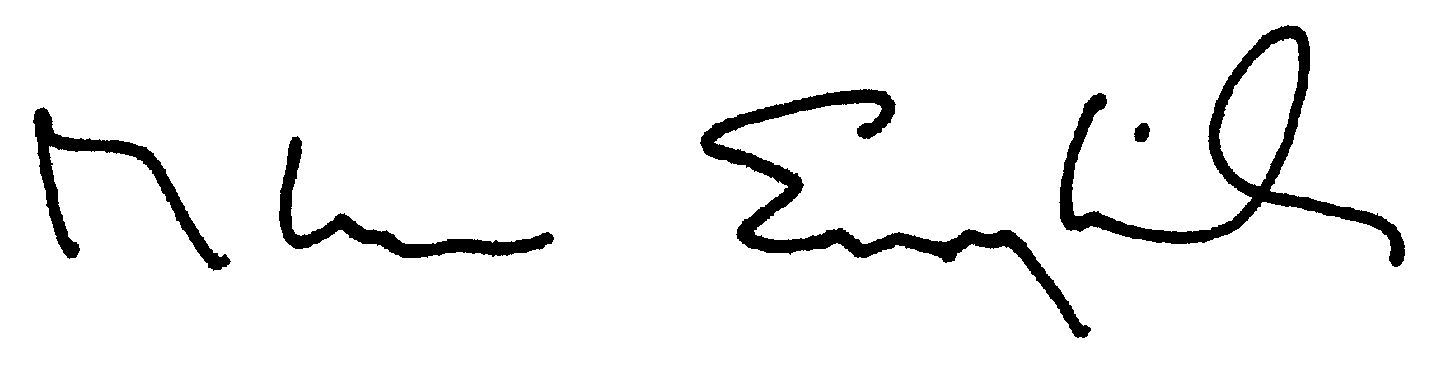

Glenn English

