LOGO HERE

2023 Legislative Action Plan

[Document subtitle]

# 2023 Legislative Action Plan

## VISION

The Senior Consultant for Civic, Charitable & Government Affairs is recognized by internal and external constituencies, and other organizations as:

* Knowledgeable with advanced proficiency about local, state and federal political issues as well as legislative processes
* Responsive to requests for assistance by external and internal stakeholders
* An effective advocate to advance SECO Energy’s mission

## MISSION

Develop and nurture relationships with local, state, federal elected officials and community leaders. Dedicated to:

* Creating Awareness
  + Strengthen visibility of SECO Energy as a state and national customer satisfaction distribution utility leader in the energy industry
* Building Relationships
  + Facilitate opportunities to develop strategic relationships with legislators, community and business leaders
  + Engage in collaborative partnerships with business and community leaders

## INTRODUCTION & BACKGROUND

Senior Consultant of Civic, Charitable & Government Relations is responsible for facilitating, coordinating and maintaining interaction with the federal, state and local governments, including the federal, state or local executive branches and executive agencies; the Congress; the State Legislature; Citrus, Marion, Lake and Sumter County Commissions and a host of city and town councils; any federal, state or local public/ private entity whose primary responsibility is interacting with or influencing the federal, state or local government. In addition, the position will develop and maintain a positive image for SECO and work to strengthen the lines of communication by serving as liaison between SECO, the business community and the community at large.

## Plan GOAL Overview

Build a broad-based support to advance the mission. With specific initiatives and tactics for government relations, community contacts and collaboration, these goal/objectives are in three areas: Federal and State Legislators, Local Government and Community.

* Increase SECO’s visibility on a local, state and federal level
* Strengthen community awareness through charitable initiatives
* Maintain an open and productive presence as SECO’s liaison at various meetings and events
* Sustain a position on community boards, working groups and committees
* Monitor city and county meeting agendas and media reports to gain an understanding of community concerns and outlook as it relates to SECO Energy
* Devote time to promote excellent public and customer relations with significant involvement in appropriate community and government activities

## Objectives & action steps

**Step #1:** Make direct interactions with federal and state legislators

**Action Steps:**

* Conduct face-to-face meetings with elected officials by getting to know the representatives and their staffers.
* Monitor and engage with legislators on their social media platforms like Facebook and Twitter
* Share and Retweet posts that align with our core values
* Attend federal and state cooperative “Legislative Day”
* Learn representatives’ issues and priorities by visiting their websites, gaining access to their newsletters and following them on social media
* Stay up-to-date on state and national activity
* Engage in a monthly letter writing and/or email campaign on a timely subject that includes a copy of our *Newsletter*
* Write brief handwritten letters addressing specific topics pertaining to policies affecting the energy industry
* Mail legislators/officials Christmas and Birthday cards
* Maintain [legislative corner](https://secoenergy.com/legislative-corner/) section on SECOenergy.com devoted to encouraging member participation in the democratic process on a state and federal level
* Deliver a copy of the Annual Report (March) with a low price point branded giveaway
* Invite legislators/officials to tour Seminole/SECO facilities
* Engage with legislators on social media – finding ways to support causes that align with SECO’s core values
* Keep elected officials informed of SECO’s restoration plans during hurricane disasters with daily email and/or phone call updates
* Emergency Restoration Communication Plan – Send VIP E-Blast to legislatives during a natural disaster or emergency situation – Sample on following page

**Step #2:** Support federal and state political candidates who speak for and protect the interest of electric cooperatives regardless of party affiliations through promoting the grassroot Political Action Committee (PAC) Campaign to Trustees, employees and cooperative members

**Action Steps:**

* Conduct face-to-face Action Committee for Rural Electrification (ACRE) meetings with employees to explain and promote the PAC initiative
* Promote ACRE Co-op Owners Political Action Committee (COPA) to members
* Coordinate, process and maintain contribution reports with the payroll department, National Rural Electric Cooperative Association (NRECA) and Florida Electric Cooperative association (FECA)

Emergency Restoration Communication Plan – E-Blast Sample:

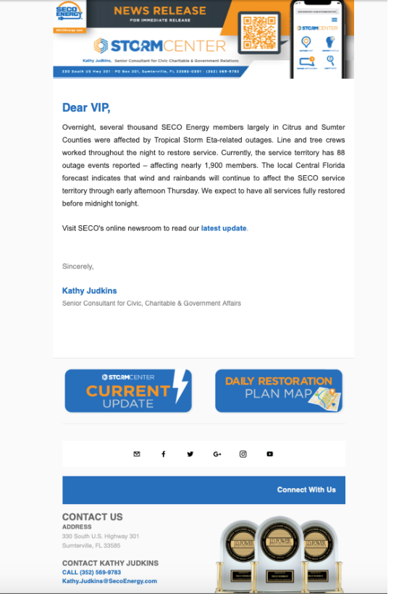

## Target Contact Demographics

| Federal Government | Legislative Delegation List – SECO Energy Territory | Term Ends | Birthday |
| --- | --- | --- | --- |
| [Rick](https://www.billnelson.senate.gov/) Scott | U.S. Senator |  | December 1 |
| [Marco Rubio](https://www.rubio.senate.gov/public/) | U.S. Senator |  | May 28 |
| [Kat Cammack](https://cammack.house.gov/) | U.S. House of Representative |  | February 16 |
| [Daniel Webster](https://webster.house.gov/) | U.S. House of Representative |  | April 27 |
| [Michael Waltz](https://waltz.house.gov/) | U.S. House of Representative |  | January 31 |
| [Gus Bilirakis](https://bilirakis.house.gov/) | U.S. House of Representative |  | February 8 |

| State Government | Legislative Delegation List – SECO Energy Territory | Term Ends | Birthday |
| --- | --- | --- | --- |
| [Dennis Baxley](https://www.flsenate.gov/Senators/s12) | FL Senator |  | August 22 |
| [Keith Perry](https://www.flsenate.gov/Senators/s8) | FL Senator |  | December 3 |
|  |  |  |  |
| [Stan McClain](http://www.myfloridahouse.gov/Sections/Representatives/details.aspx?MemberId=4658&LegislativeTermId=87) | FL House of Representative |  | July 7 |
| [Keith Truenow](https://www.myfloridahouse.gov/Sections/Representatives/details.aspx?MemberId=4772&LegislativeTermId=89) | FL House of Representative |  | August 9 |
| [Yvonne Hayes Hinson](https://www.myfloridahouse.gov/Sections/Representatives/details.aspx?MemberId=4768&LegislativeTermId=89) | FL House of Representative |  | November 30 |
| [Ralph Massullo](http://www.myfloridahouse.gov/Sections/Representatives/details.aspx?MemberId=4624&LegislativeTermId=87) | FL House of Representative |  | December 25 |
| Taylor Yarkosky | Florida House of Representative |  |  |
| John Temple | Florida House of Representative |  |  |
| Ryan Chamberlin | Florida House of Representative |  |  |
|  |  |  |  |

## timeline for action

| MONTH | STATE | FEDERAL | Planning Needs |
| --- | --- | --- | --- |
| **January** | Mail *SECO News*  Mail Annual Meeting Invitation | Mail *SECO News*  Mail Annual Meeting Invitation | Start Preparing for Annual Meeting and ACRE Cookout |
| **February** | Mail *SECO News* | Mail *SECO News*  Mail Birthday cards –Cammack, Bilirakis & Dunn |  |
| **March** | Mail *SECO News*  Attend ACRE Cookout - Tallahassee  Deliver Annual Meeting Report  Mail Birthday cards – Stargel | Mail *SECO News*  Deliver Annual Meeting Report  Mail Birthday cards - |  |
| **April** | Mail *SECO News* | Mail *SECO News*  Mail Birthday cards – Webster  Attend NRECA Conference - Washington |  |
| **May** | Mail *SECO News* | Mail *SECO News*  Mail Birthday cards – Rubio |  |
| **June** | Mail *SECO News*  Mail Birthday cards – Simpson & Harding | Mail *SECO News* |  |
| **July** | Mail *SECO News*  Mail Birthday cards - McClain | Mail *SECO News* |  |
| **August** | Mail *SECO News*  Mail Birthday cards – Baxley & Truenow | Mail *SECO News*  Mail Birthday cards – |  |
| **September** | Mail *SECO News*  Mail Birthday cards – Bradley & DeSantis | Mail *SECO News* | Purchase Christmas Cards |
| **October** | Mail *SECO News*  Mail Birthday cards – Hage & Sabatini | Mail *SECO News* |  |
| **November** | Mail *SECO News*  Mail Birthday cards – Hinson  Invite for SECO or Seminole Tour  Create welcome letter for newly elected officials | Mail *SECO News*  Invite for SECO or Seminole Tour  Create welcome letter for newly elected officials |  |
| **December** | Mail *SECO News*  Mail Christmas Cards  Mail Birthday cards – Perry & Massullo | Mail *SECO News*  Mail Christmas Cards  Mail Birthday cards – Scott | Create Annual Meeting Save the Date VIP letter |

**Step #3:** Proactively promote a plan to review city and county government policies and economic development activities that impact the economies within SECO’s territory.

**Action Steps:**

* Monitor local government meeting agendas
* Conduct face-to-face meetings with elected officials
* Stay up-to-date on local activity
* Attend local government council meetings
* Attend legislative delegation meetings

## Target Contact Demographics

| Local Government Agencies – SECO (four primary counties) Territory | |
| --- | --- |
| Marion County Board of Commissioners | City of Eustis |
| City of Dunnellon | City of Mount Dora |
| City of Ocala | City of Umatilla |
| City of Belleview | City of Clermont |
| Citrus County Board of Commissioners | Town of Astatula |
| City of Inverness | Town of Montverde |
| Lake County Board of Commissioners | City of Minneola |
| City of Groveland | Town of Lady Lakes |
| City of Leesburg | City of Fruitland Park |
| City of Mascotte | Sumter County Commissioners |
| Town of Howey-In-The-Hills | City of Bushnell |
| City of Tavares | City of Wildwood |

**Step #4:** Demonstrate a supportive attitude toward the business community that supports SECO’s initiatives.

**Action Steps:**

* Attend business networking meetings
* Participate in focus groups activities
* Influence policymaking decisions by serving on various community committees and boards

## Target Contact Demographics

| Local Chambers and Economic Development – SECO (four primary counties) Territory | |
| --- | --- |
| Ocala/Marion Chamber & Economic Development Partnership | Eustis Chamber |
| Sumter County Chamber | Umatilla Chamber |
| Lady Lake Chamber | South Lake Chamber |
| Tavares Chamber | Citrus Chamber |
| Citrus Economic Development | Lake Economic Area Development |
| Sumter County Board of Commissioners | Dunnellon Chamber |