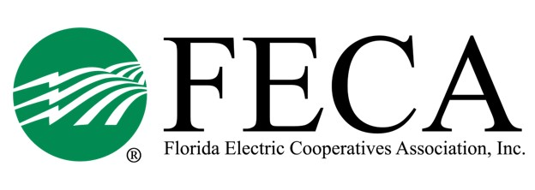
2024 Lobby Clinic
FECA (2916 Apalachee Pkwy, TLH)

TENTATIVE AGENDA

Monday, December 11
11:30 PM Lunch available
12:00 PM Welcome/Safety/Attendee Intro Drew Love/Alisia Hounshell
12:15 PM DC Overview Michael Nolan
01:30 PM Break
01:45 PM DC Initiatives Amy Lewis, NRECA
02:30 PM Grassroots (VCP, Co-ops Vote & PAC) Amy Lewis, NRECA
03:00 PM Break
03:15 PM Why We Lobby State Elected Official, TBD
04:00 PM Adjourn
05:00 PM Optional Social Hour Casa Tapas & Cantina

Tuesday, December 12
*breakfast available at hotel*
08:30 AM Statewide Synopsis Drew Love/Mike Bjorklund
09:15 AM Storms & Politics Kaitlynn Culpepper, Tri-County EC
& Jon Little, Suwannee Valley EC
10:00 AM Break
10:15 AM Blue Skies & Farm Teams Kathy Judkins, SECO Energy
11:00 AM Resource Wrap up Alisia Hounshell
11:30 AM Close out/Announcements FECA

