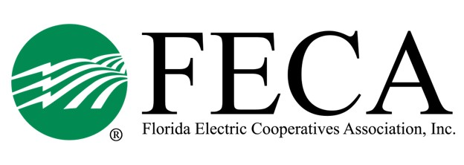
2023 Lobby Clinic
FECA (2916 Apalachee Pkwy, TLH)

TENTATIVE AGENDA

Tuesday, January 24
11:30 PM Lunch available
12:00 PM Welcome/Safety/Attendee Intro Drew Love/Alisia Hounshell
12:15 PM Issues in DC Gabe Snow, NRECA
01:00 PM Grassroots Gabe Snow, NRECA
01:45 PM Break
02:00 PM ACRE Gabe Snow, NRECA
02:45 PM Federal Elections/Lay of the Land Michael Nolan
04:00 PM Adjourn
05:00 PM Optional Social Hour Georgio’s (2971 Apalachee Pkwy)

Wednesday, January 25
08:00 AM Breakfast
08:30 AM State Elections – Lay of the Land Drew Love
09:00 AM State issues Mike Bjorklund/Drew Love
09:30 AM Break
09:45 AM Why we lobby? Elected Official
11:00 AM Roundtable
11:30 AM Close out/Announcements Drew Love

