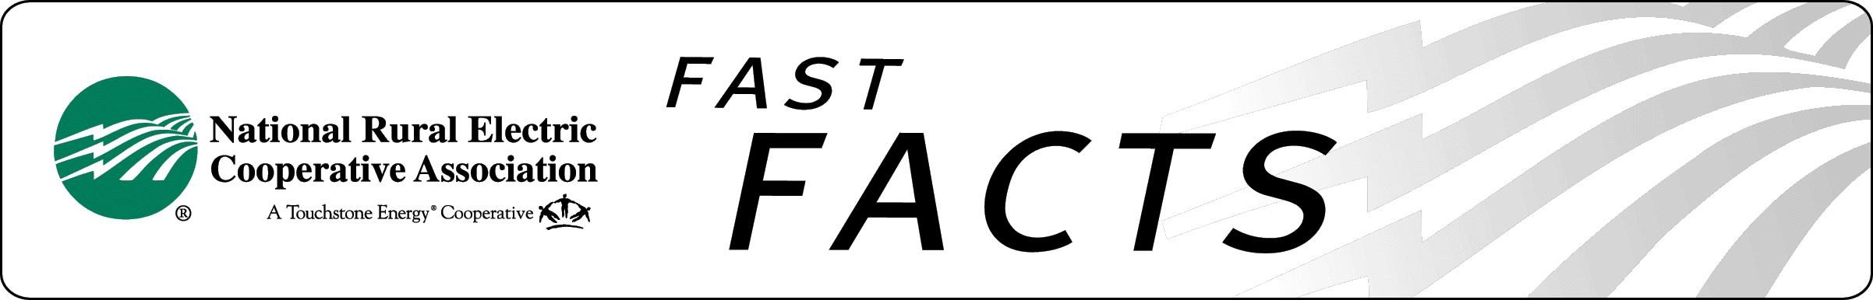

**Coal Combustion Residuals Benefits**

Coal Combustion Residuals (CCRs) are materials produced when coal is burned to generate electricity. CCRs are used beneficially in a variety of applications including sustainable construction practices. For example, CCRs are used to enhance the strength and durability of concrete. Over forty percent of the CCRs produced are recycled and/or put to beneficial use.

The U.S. Environmental Protection Agency (EPA) has proposed federal regulations governing the disposal of CCRs under the Resource Conservation and Recovery Act (RCRA). EPA is weighing two options for CCR management under RCRA including regulating CCRs as hazardous waste under RCRA Subtitle C or regulating CCRs as non-hazardous under RCRA Subtitle D.

Whether or not to regulate CCRs as hazardous has been researched for nearly three decades and the overwhelming conclusion is that CCRs do not warrant hazardous regulatory treatment. EPA itself, in two prior reports to Congress and two related regulatory determinations, confirmed that regulating CCRs under RCRA Subtitle C is not necessary to protect public health and the environment.

NRECA agrees that regulating CCRs under RCRA’s hazardous waste rules is not warranted. NRECA opposes the hazardous regulatory option set forth in EPA’s proposed rule. In addition to reducing the rate of beneficial use, hazardous regulatory treatment of CCRs will create significant compliance costs at coal-based generation facilities. These costs could render some units uneconomic, leaving plant closure the only viable option.

Adding to the regulatory uncertainty is a lawsuit filed against EPA on April 5, 2012 by a coalition of environmental groups that are advocating for hazardous regulation of CCRs. The lawsuit is designed to force a hard legal deadline for release of the rule which could limit EPA’s ability to fully and carefully select the proper regulatory path forward for CCRs.

In order to resolve the regulatory uncertainty associated with this issue, NRECA is actively supporting the Coal Residuals Reuse and Management Act (H.R. 2273/S. 1751), legislation to establish a federal regulatory program to ensure the safe management of CCRs as a non-hazardous material. H.R. 2273 was passed by the U.S. House of Representatives on October 14, 2011, on a strong bipartisan vote and recently adopted as an amendment to H.R. 4348, the House 90-day highway bill extension. S. 1751 was introduced with bipartisan backing in the U.S. Senate on October 20, 2011.

NRECA is urging the U.S. Senate to follow the House’s lead by taking up and approving S. 1751.

for more information

##### John Cassady, NRECA

703.907.5839

[john.cassady@nreca.coop](mailto:john.cassady@nreca.coop)

<http://www.nreca.coop>

