April 24, 2012

Dear Members of the House of Representatives:

On behalf of the National Rural Electric Cooperative Association (NRECA), I am writing to express our strong support for H.R. 3336, the Small Business Credit Availability Act that is expected to be considered by the House of Representatives on April 25, 2012. H.R. 3336 includes language that protects the National Rural Utilities Cooperative Finance Corporation (CFC) and its rural electric cooperative borrowers from the costs of excessive regulations under the Dodd-Frank Wall Street Reform and Consumer Protection Act of 2010.

NRECA is the national service organization representing over 900 not-for-profit, member-owned, rural electric cooperative systems, which serve 42 million customers in 47 states. CFC is a cooperative financial institution formed by and owned by rural electric cooperatives. NRECA estimates that cooperatives own and maintain 2.5 million miles or 42 percent of the nation’s electric distribution lines covering three-quarters of the nation’s landmass. Electric cooperatives serve approximately 18 million businesses, homes, farms, schools and other establishments in 2,500 of the nation’s 3,141 counties.

H.R. 3336, the Small Business Credit Availability Act introduced by Congresswoman Vicky Hartzler exempts small banks, credit unions and farm credit system lenders from certain regulations under the Dodd-Frank Act that Congress intended to apply to larger banks. Appropriately, H.R. 3336 also includes CFC among the list of small lenders that should be exempt from the definition of “financial entity” in the Dodd-Frank Act and therefore exempt from burdensome and costly regulations that would ultimately be borne by electric cooperative consumer-members.

On behalf of rural electric cooperatives across the country, NRECA would like to thank Congresswoman Hartzler, and the leaders of the House Agriculture Committee, for seeking to clarify in statute that a non-profit cooperative lender and its rural electric cooperative borrowers do not pose risk to our financial system, and need not be regulated in the same way as a Wall Street bank.

We would like to urge all members of the House of Representatives to vote in support of H.R. 3336, the Small Business Credit Availability Act.

Sincerely,
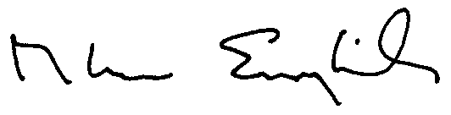
Glenn English
Cc: The Hon. Frank Lucas
The Hon. Collin Peterson
The Hon. Vicky Hartzler

