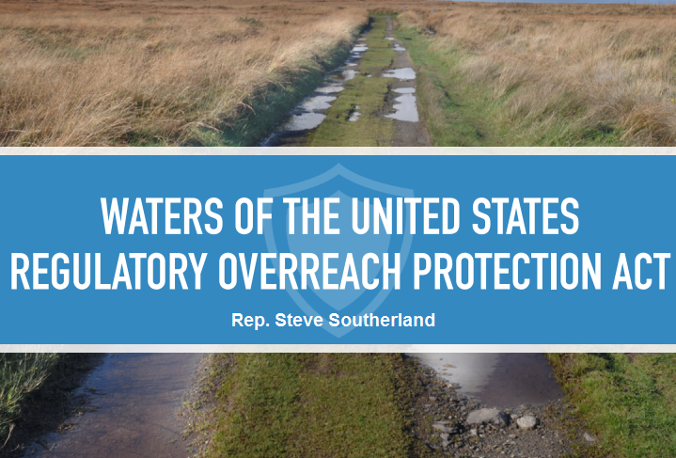

**The *Waters of the United States Regulatory Overreach Protection Act*, H.R. 5078, prevents the Environmental Protection Agency from implementing a new rule that would grant them the authority to regulate nearly any body of water or wet area in America - including ditches, culverts, pipes, desert watersheds, and farmland ponds.**

**Rep. Southerland's bipartisan bill stops the unprecedented federal power grab and upholds the balanced federal-state partnership that has historically regulated our nations' waters.**

Specifically, H.R. 5078:

* Prohibits federal agencies from moving forward with the proposed rule.
* Prohibits an additional "interpretive rule" that would limit current exemptions for agriculture conservation practices.
* Requires federal agencies to consult with local and state officials to formulate a consensus proposal to identify which waters should be federally regulated and which should be left to the states to regulate.

H.R. 5078 was approved unanimously by the House Committee on Transportation and Infrastructure on July 16, 2014, and was filed with 120 cosponsors on July 31, 2014. It is expected to be considered by the full House in September 2014.