Busy Legislative Session Adjourns
The Florida Electric Cooperatives Association’s (FECA) primary focus is to monitor and analyze bills and work with legislators on any legislation impacting you, our consumer-members, while ensuring our not-for-profit electric co-ops are able to continue their mission in providing safe, reliable, and affordable electricity. Much of this is handled during Florida’s legislative session which ended on March 14, 2022.
This session, the Florida Legislature was required to complete the process of redrawing state legislative and congressional boundaries, called redistricting. This requires apportioning each seat with an equal number of constituents to ensure citizens receive representation. The Legislature successfully passed the House and Senate legislative maps. In early March, the Florida Supreme Court upheld the validity of the new district lines for the state House and Senate maps, although legal challenges could still be filed by various groups in other courts. The House and Senate passed two Congressional District maps but await action by the Governor and any challenges brought to the courts.
Since the pandemic, the Legislature has prioritized helping rural and unserved areas receive broadband Internet services. Last year, the Legislature created the Broadband Opportunity Grant Program to fund the installation or deployment of infrastructure that supports broadband Internet service in unserved areas; funding was not included. This year, part of Florida’s $112 billion budget provides $400 million to implement the program. Grant awards will be handled by the Department of Economic Opportunity’s Office of Broadband. Those applying for the dollars must provide a description of the project area; a description of the kind and amount of broadband Internet service infrastructure that is proposed to be deployed; evidence demonstrating the unserved nature of the project area; the number of households and businesses that would have access to broadband Internet service as a result of the grant; and the total cost of the project and the timeframe in which it would be completed. We look forward to our continued collaboration with the Office of Broadband to help our communities and their need to receive these vital services.
Also, Florida passed a Tax package that includes the following sales tax holidays:
- May 28 – June 10, 2022 “Disaster Preparedness” Holiday
- July 1 – July 7, 2022 “Freedom Week” Holiday
- July 25 – August 7, 2022 “Back-to-School” Holiday
- September 3 – September 9, 2022 “Tool Time” Holiday
- October 2022 “Gas Tax” Holiday
To learn more, visit https://www.flsenate.gov/Media/PressReleases/Show/4133 for more information on what is covered during each sales tax holiday.
As the Legislative Session finishes, the road to the mid-term elections in November will be very busy in Florida. U.S. Senator Marco Rubio, all 28 U.S. Congressional seats, all 160 Florida Legislative seats, and the entire Florida Cabinet will be on the ballot. Now more than ever, making your voice heard on election day vital. Visit www.vote.coop to learn more about issues affecting electric co-ops, information on your elected officials, and important election dates.
**Think about including Co-ops Vote logo here **
It is critical that Florida’s not-for-profit electric cooperatives remain strong and continue providing safe, reliable, and affordable electricity to consumer-members in their communities. We all play a part in the legislative process and we are proud of our role in making sure Florida’s electric co-ops contribute to our communities’ overall success.

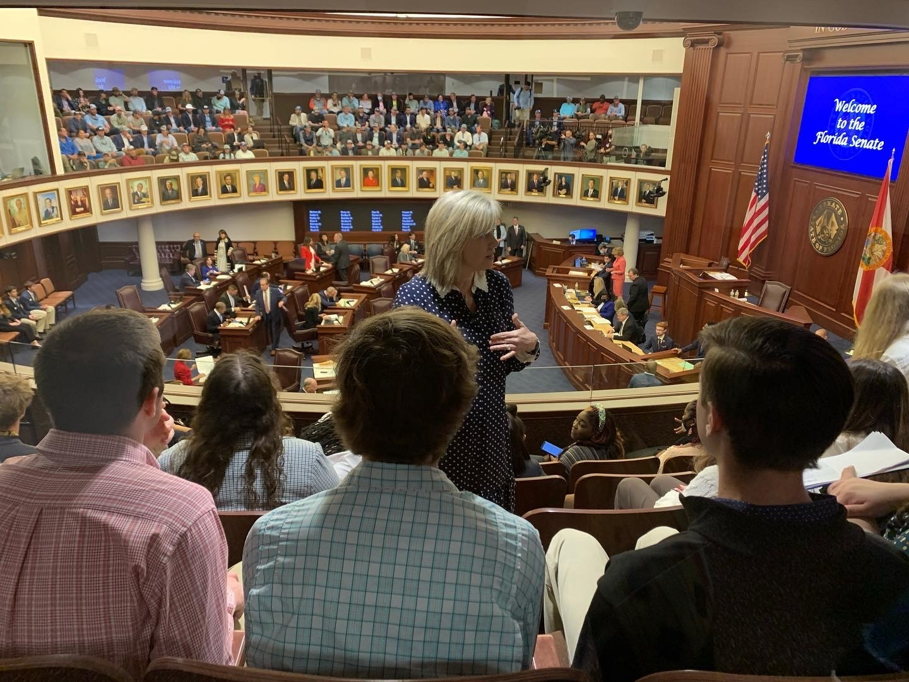
In February, Florida Electric Cooperative Youth Tour students listen on as FECA’s Director of Government Affairs, Allison Carter, explains what is happening on the Florida Senate floor below.

