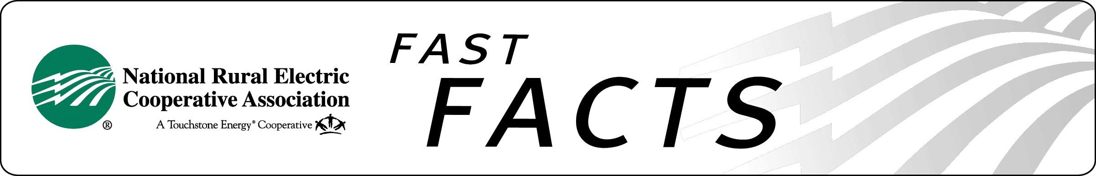

### Federal Emergency Management Agency (FEMA) Funds

**FEMA Funds Allow Not-For-Profit Electric Cooperatives**

**to Restore Power and Hope to Disaster Areas**

Electric cooperatives (co-ops) rely on reimbursements by FEMA’s Public Assistance program for funds to restore electric power after severe disasters – such as floods, hurricanes, tornadoes, and ice storms. Without FEMA reimbursement assistance, many electric cooperative consumers living in disaster areas could face higher rates and struggle with recovery causing slower recovery periods.

Under current federal law and policy, all utility systems receive federal funds and/or assistance for recovery after Presidentially-declared disasters. Investor-owned utilities, as for-profit entities, can use federal tax deductions and allocations to offset expenses for restoring power. Not-for-profit co-ops cannot access these tax advantages. Decades ago, Congress selected FEMA funds as the appropriate vehicle to offset Presidentially-declared disaster expenses incurred by electric cooperatives.

Congress took note of several facts about the cooperative business model when it amended the Stafford Act to include electric cooperatives in the FEMA Public Assistance Program. Although cooperatives serve only 12 percent of the nation’s consumers, they operate and maintain nearly half of the nation’s local distribution lines that span across approximately 2,500 counties.

Cooperative service territory density, at an average of only seven customers per mile of line, is the lowest in the industry. As a result, most electric cooperatives must depend on a small consumer base to operate in their large geographic service areas.  And, as not-for-profit utilities, electric cooperatives can only spread costs among their own consumer-owners.

Under the Stafford Act’s Public Assistance Program, when electric cooperative service territory is included in a Presidentially-declared disaster area, FEMA may reimburse up to 75 percent of the allowed costs of replacing damaged and lost facilities for electric cooperatives. The cooperative provides the matching funds and ultimately is responsible for restoring service to pre-disaster levels. The cooperative is also obligated to keep its lenders whole by ensuring that lines, poles and facilities are replaced.

After some significant disasters, for-profit entities have asked Congress to include them in the Stafford Act’s protections. However, Congress has historically declined to do this, citing to the fact that for-profit entities can count losses incurred in disasters against their federal tax obligations. In some cases, notably after September 11th and Hurricanes Katrina, Rita, and Sandy, for-profit entities accessed these tax advantages and received significant monetary assistance through federal disaster Community Development Block Grants.

**FEMA Policy 9580.6, Electric Utility Repair**

In 2009, FEMA adopted policy 9580.6, Electric Utility Repair, establishing criteria to determine eligibility for repair or replacement of disaster-damaged electric distribution and transmission systems. The policy is intended to standardize the criteria for determining when electric cooperatives’ storm–impacted systems are damaged and the actions to take to either repair certain components of those systems or to rebuild to the damaged line sections to current codes and standards (reconductoring). It sets forth specific visually-observable criteria for determining if the power line is damaged beyond the point where it can be effectively repaired. No testing of physical characteristics of the damaged conductor is required under the policy.

However, in 2013, cooperatives in FEMA Region 7 – specifically Iowa - were denied assistance for repairs suffered during a late winter storm. FEMA Region 7 determined that these cooperatives were not able to prove their electric line was damaged during the April storm event because physical testing of the overhead line was not performed prior to and following the storm. FEMA wanted the co-op to cut out 20 feet of line per mile of line they own, and send that segment to a lab for testing each and every year – a practice clearly not envisioned in FEMA’s written policy. There are many reasons why tests of this type are not conducted in Iowa, or anywhere else – chiefly the physical impact to the system of snipping apart the lines.

FEMA has never before required electric cooperatives to physically test their electric line before and after storm events to support applications for FEMA disaster recovery funds. This decision is currently under appeal.

**The Electric Cooperative Position**

NRECA urges Congress to carefully weigh all pending and future proposals for retooling or overhauling FEMA. In its current form, the Public Assistance Program is an effective tool for enabling electric cooperatives to quickly restore electric service to consumers’ homes and businesses. The Public Assistance Program’s inclusion of not-for-profit entities like electric cooperatives should be maintained. For-profit utilities, which can offset disaster costs by using provisions of the federal tax code, should not gain access to FEMA funding.

**Ask your delegation to ensure there is sufficient oversight of FEMA so that FEMA policies are consistently applied and in line with established practices.**

for more information

**Bridgette Bourge, NRECA**

703.907.6386

[Bridgette.Bourge@nreca.coop](mailto:Bridgette.Bourge@nreca.coop)

<http://www.nreca.coop>

