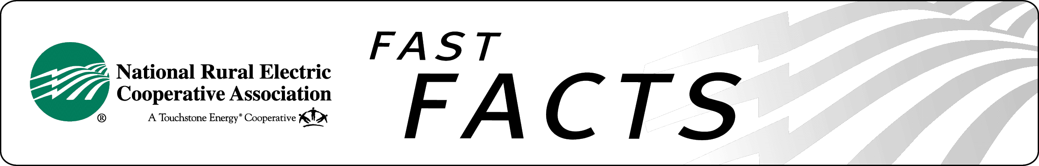

NRECA’s International Rural Electrification Programs
Electrify Africa Act

Issue: For 50 years, NRECA International has provided people in developing countries with access to safe, reliable and affordable electricity. These electrification programs have resulted in increased agricultural productivity, millions of new jobs in micro and small enterprises, and higher incomes and quality of life for rural communities in more than 42 countries around the world.

Yet, more remains to be done, especially in sub-Saharan Africa, where 68 percent of the population or 589 million people live without the benefits of electric power. The lack of electricity impacts people’s lives resulting in limited economic growth with a disproportionately negative impact on women and girls who are particularly vulnerable after nightfall.

History has shown that prioritized foreign assistance funding has put many countries on a path toward a stronger future. Aggressive and sustained overseas rural development programs that include cooperative electrification directly improve health and social well being, job and educational opportunities, and elevate income and living conditions for people in developing nations. Furthermore, cooperatives directly convey the American system of democratic participation and governance. Electric power is the foundation for dramatic increases in local standards of living, quality of life, and economic development. The cooperative model used by NRECA has proven to be one of the most effective implementing systems for delivering safe and reliable electricity to the developing world.

NRECA Position: The goal of the Electrify Africa Act, H.R. 2548, is to ensure that our foreign aid investments in sub-Saharan Africa are sustainable and successful. According to a CBO study, the legislation would save the federal government $86 million over the 2014-2019 period. It is a revenue generator that sets a comprehensive, multi-year strategy to achieve these goals. NRECA supports the legislation and stands ready to partner with the U.S. government to achieve this goal. As the rural electrification access experts, NRECA works to establish an infrastructure that will withstand the test of time. The Electrify Africa Act prioritizes and coordinates U.S. government resources to achieve three goals in sub-Saharan Africa by 2020:

- Encourage the installation of at least an additional 20,000 megawatts of electrical power.
- Promote first-time access to electricity for at least 50 million people, particularly the poor.
- Promote efficient institutional platforms that provide electrical service to rural and underserved areas.

Ask your Members of Congress to support H.R. 2548 when it comes to the House floor.

Ask your Senators to co-sponsor the Senate bill.

For more information, contact:

Abbie Laugtug, NRECA
703.907.5822
abbie.laugtug@nreca.coop
http://www.nreca.coop

