**FLORIDA ELECTRIC COOPERATIVES ASSOCIATION**

**2016 HUMAN RESOURCES CONFERENCE**

**Sandpearl Resort-Clearwater Beach, Florida-Sept. 14-16**

**Wednesday, September 14 – Joint Session HR and F&A**

2:00 – 3:00pm **Jason Settle, Hi-Line Engineering**

Topic: The Basic Electric Distribution System Explained

*Jason will discuss the basics of working with and around power lines including general safety rules and guidelines*

3:00 – 3:15p.m. **Break**

3:15 – 5:00p.m. **Jason Settle, Hi-Line Engineering (continued)**

**Thursday, September 15 – Breakout Session for HR Only**

7:30 - 8:30am: **Full Breakfast Buffet – Sponsored by CoBank**

8:30 - 8:45am: Welcome and Introductions

8:45 - 10:00am: **Bert Brannen, Esq.**

Fisher & Phillips, LLP

1075 Peachtree Street, NE

Suite 3500

Atlanta, GA 30309

(404) 240-4235

*Topic: Hot Topics In Employment Law For 2016*

10:00 - 10:15am: Break

10:15 - Noon: **Bert Brannen, Esq.**

Fisher & Phillips, LLP

*Topic: Hot Topics in Employment Law For 2016- Violence in the Workplace*

Noon - 1:00pm: Lunch On Your Own

1:00 – 2:00pm **Terri Sapp, USIS**,

Topic: Review of New USIS Website, Light Duty Work, Surveillance of Injured Workers

2:00- 2:40pm **Jason Feider**, **NRECA**

Topic: The State of U.S. Healthcare

2:40pm – 3:00 **Brian Grogan, Federated Update**

3:00 - 3:15pm: Break

3:15 – 4:00pm: **Michael Frizzel, MDF HR Consulting**

Topic: “Anti-Trust Regulations Applied to Electric Cooperatives”

4:00 – 5:00p.m. **Neil Dickinson, HudsonMann**,

TOPIC: Affirmative Action

**5:30 – 7:00pm SPONSOR’s RECEPTION AT THE BROWN BOXER**

**Friday, September 15 – Joint Session HR and F&A**

7:15 – 8:30a.m. **Breakfast at Caretta Restaurant, First Floor Sandpearl**

**Sponsored By CFC**

8:30 – 9:30a.m. **Dan Sharpe/Jason Feider, NRECA Update**

9:30 – 9:45a.m. **Break**

9:45 – 11:15a.m. **Bryan Singletary, President, Practical Energies**

Topic: The need for sound training for employees from a supervisory perspective to ensure you are well prepared to control and communicate costs and other issues associated with the new regulatory climate

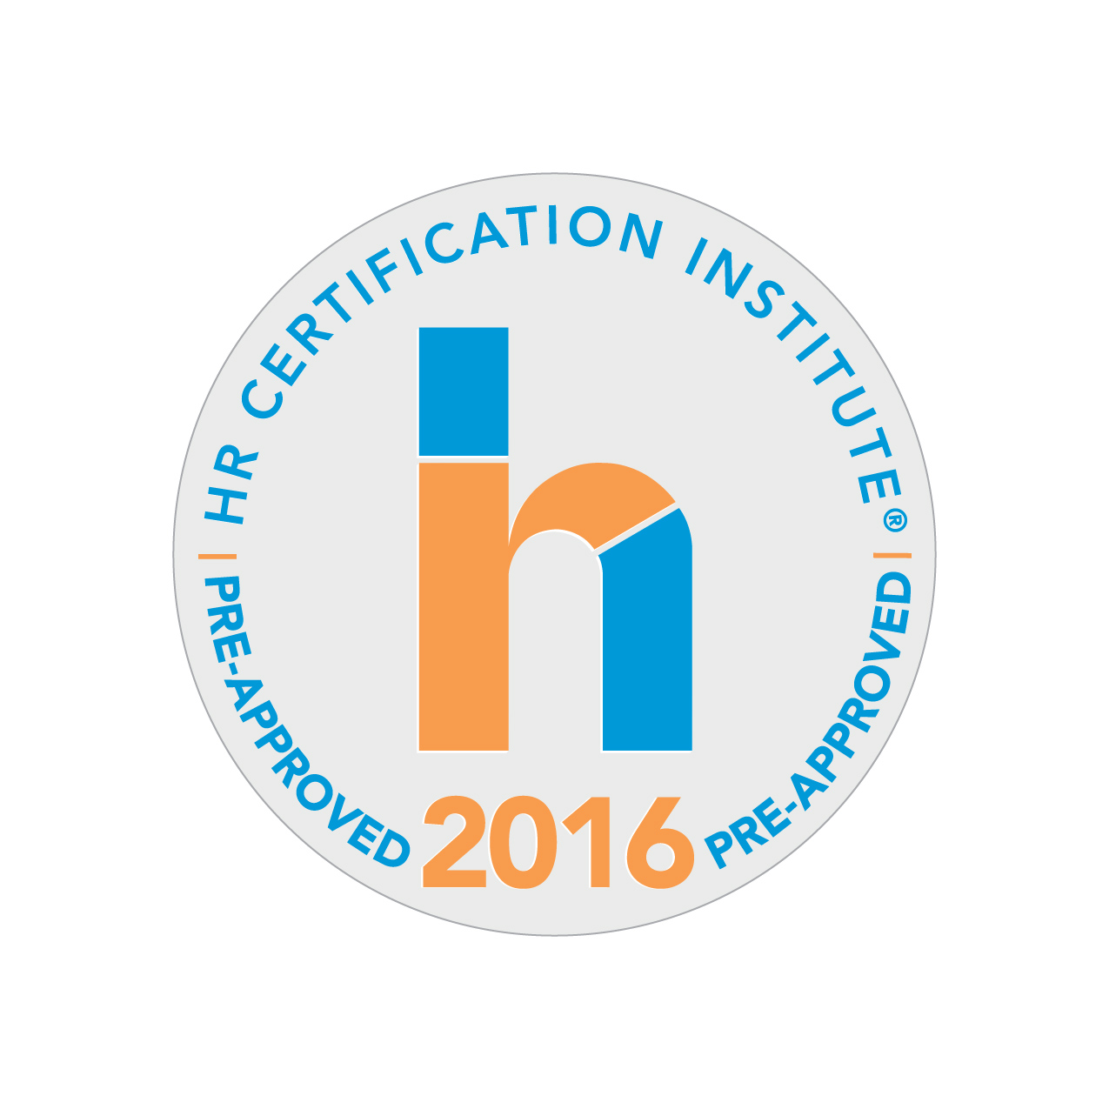

"The use of this seal confirms that this activity has met HR Certification Institute's® (HRCI®) criteria for recertification credit pre-approval."

"This activity, ID No. 279934, has been approved for Recertification Credit Hours Awarded: **6.75** Specified Credit Hours: HR (General) recertification credit hours toward aPHR™, PHR®, PHRca®, SPHR®, GPHR®, PHRi™, SPHRi™ recertification through HR Certification Institute's® (HRCI®). Please make note of the activity ID number on your recertification application form. For more information about certification or recertification, please visit the HR Certification Institute website at [www.hrci.org](http://www.hrci.org)."