Commissioners:  Art Graham, Chairman  Julie I. Brown  Donald J. Polmann  Gary F. Clark | State of Florida  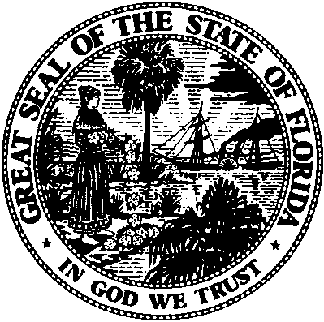 | Office of the General Counsel  Keith C. Hetrick  General Counsel  (850) 413-6199
Public Service Commission
January 19, 2018

STAFF’S THIRD DATA REQUEST
Via E-mail

To:

Municipal Group (AZubaly@publicpower.com)
Lee County (dennie.hamilton@lcec.net)
Cooperative Group (mhershel@feca.com)

Re: Docket No. 20170215-EU - Review of electric utility hurricane preparedness and restoration actions.
To Whom It May Concern:
By this letter, the Commission staff requests that each utility provide responses to the following data requests.

- Please provide the following information for a specific example where storm hardened structures incurred damage and required repair or replacement due to Hurricane Irma.
- A description of the damage incurred (i.e. broken pole, displaced underground vault, etc.).
- A description of the repair process, including a description of any temporary repairs that required a follow-up trip.
- A description of the repair process if the facilities had not been hardened.

Please file all responses electronically no later than February 19, 2018 from the Commission’s website at www.floridapsc.com, by selecting the Clerk’s Office tab and Electronic Filing Web Form. Please contact me at wtaylor@psc.state.fl.us or at 850.413.6175 if you have any legal questions, or contact Emily Knoblauch for technical questions at eknoblau@psc.state.fl.us or at 850.413.6632.

Sincerely,

/s/Wesley Taylor

Wesley Taylor
Attorney

WDT/as

cc: Office of Commission Clerk
Office of Public Counsel (kelly.jr@leg.state.fl.us, sayler.erik@leg.state.fl.us)

