**Report on Collaborative Research for Hurricane Hardening**

Provided by

The Public Utility Research Center

University of Florida

To the

Utility Sponsor Steering Committee

Final Report dated April 2022

**I. Introduction**

The Florida Public Service Commission (FPSC) issued Order No. PSC-06-00351-PAA-EI on April 25, 2006 (Order 06-0351) directing each investor-owned electric utility (IOU) to establish a plan that increases collaborative research to further the development of storm resilient electric utility infrastructure and technologies that reduce storm restoration costs and outages to customers. This order directed IOUs to solicit participation from municipal electric utilities and rural electric cooperatives in addition to available educational and research organizations. As a means of accomplishing this task, the IOUs joined with the municipal electric utilities and rural electric cooperatives in the state (collectively referred to as the Research Collaboration Partners) to form a Steering Committee of representatives from each utility and entered into a Memorandum of Understanding (MOU) with the University of Florida’s Public Utility Research Center (PURC). In 2018 the Research Collaboration MOU was renewed for an initial term of two years, effective January 1, 2019, and will be automatically extended for successive two-year terms.

PURC performs the administration function for research collaboration, including financial management, logistics, production and distribution of documents, and preparation of reports. PURC also coordinates and performs research as agreed upon with the Steering Committee by facilitating the exchange of information from the Research Collaboration Partners with individuals conducting research projects and facilitating the progress of each research project. The collaborative research has focused on undergrounding, vegetation management, hurricane-wind speeds at granular levels, and improved materials for distribution facilities.

This report provides an update on the activities of the Steering Committee since the previous report dated February 2021.

**II. Undergrounding**

The collaborative research on undergrounding has been focused on understanding the existing research on the economics and effects of hardening strategies, including undergrounding, so that informed decisions can be made about undergrounding policies and specific undergrounding projects.

The collaborative has refined the computer model developed by Quanta Technologies and there has been a collective effort to learn more about the function and functionality of the computer code.

In addition, PURC has worked with doctoral and master’s candidates in the University of Florida Department of Civil and Coastal Engineering to assess some of the inter-relationships between wind speed and other environmental factors on utility equipment damage. PURC has also been contacted by engineering researchers at the University of Wisconsin and North Carolina State University with an interest in the model, though no additional relationships have been established. In addition to universities, PURC has been in contact with stakeholders in Puerto Rico due to PURC Director Mark Jamison’s service on the Southern States Energy Board Blue Ribbon Task Force on the future of Puerto Rico’s energy system. The stakeholders, government and task force discussed strategies to make Puerto Rico’s system more resilient and are interested in the role that the model could play. PURC has been contacted by California stakeholders interested in applying the principles of the model to the mitigation of the interactions between the electricity grid and the surrounding vegetation, potentially reducing the risk of wildfires. In the wake of Hurricane Ida, PURC has been contacted by stakeholders in New Orleans regarding the process of assessing the costs and benefits of storm hardening. Finally, PURC has been contacted by stakeholders in New York, Pennsylvania, and New Jersey with interest to model the impact of storm hardening to winter storms. Despite the outside interest, there are no concrete plans to expand the scope of the model at this time. Every researcher that contacts PURC cites the model as the only non-proprietary model of its kind.

**III. Wind Data Collection**

The Project Sponsors entered into a wind monitoring agreement with WeatherFlow, Inc., in 2007. Under the agreement, Florida Sponsors agreed to provide WeatherFlow with access to their properties and to allow WeatherFlow to install, maintain and operate portions of their wind monitoring network facilities on utility-owned properties under certain conditions in exchange for access to wind monitoring data generated by WeatherFlow's wind monitoring network in Florida. WeatherFlow’s Florida wind monitoring network includes 50 permanent wind monitoring stations around the coast of Florida, including one or more stations located on utility-owned property. The wind monitoring agreement expired in early 2012; however, it was renewed in April 2017 and will renew automatically annually on the effective date for an additional one year period, unless terminated by the parties to the agreement.

**IV**. **Public Outreach**

We have previously discussed the impact of increasingly severe storms and the increased population and utility infrastructure along the coast on greater interest in storm preparedness. PURC researchers continue to discuss the collaborative effort in Florida with the engineering departments of the state regulators in New York, New Jersey, and Pennsylvania, and regulators in Jamaica, Grenada, Curacao, St. Lucia, the Bahamas, Samoa, and the Philippines. In 2019, stakeholders in Puerto Rico and California also showed interest in the collaborative’s efforts. While all of the regulators and policymakers showed great interest in the genesis of the collaborative effort, and the results of that effort, they have not, at this point, shown further interest in participating in the research effort. In 2021, there continued to be considerable interest in Florida’s hardening efforts from the popular media in California, in light of continued wildfire problems in the state and their aftermath. Interest in Florida’s storm hardening efforts continued in the popular media with PURC Director of Energy Studies Ted Kury publishing op-eds in the Hill[1] and Barron’s[2], and featured in media outlets such as the Washington Post.

**VI. Conclusion**

In response to the FPSC’s Order 06-0351, IOUs, municipal electric utilities, and rural electric cooperatives joined together and retained PURC to coordinate research on electric infrastructure hardening. The steering committee has taken steps to extend the research collaboration MOU so that the industry will be in a position to focus its research efforts on undergrounding research, granular wind research and vegetation management when significant storm activity affects the state.

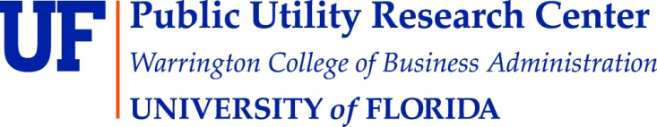

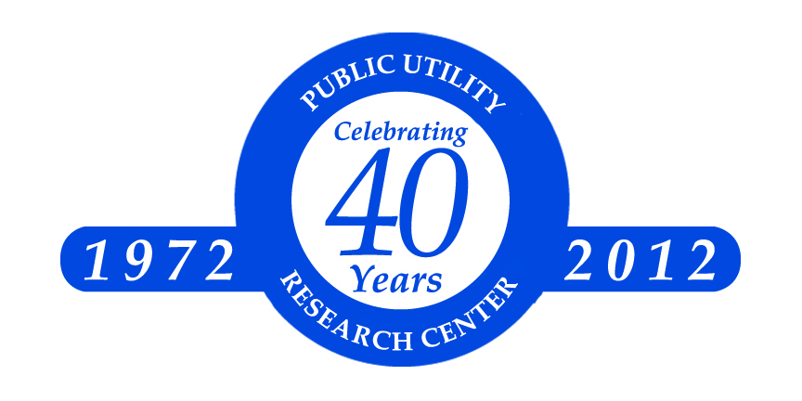

1. “No easy decisions to ensure a resilient power grid” <https://thehill.com/opinion/energy-environment/572704-no-easy-decisions-to-ensure-a-resilient-power-grid/>
2. “America’s Electrical Grids are Under Threat: For Fixes, Look to Florida” <https://www.barrons.com/articles/americas-electrical-grids-are-under-threat-for-fixes-look-to-florida-51625092251?tesla=y>